1 Laboratory work
THE STUDY OF A SCREW JOINT LOADED WITH A TRANSVERSAL FORCE

The abbreviations and their meanings:

f_{s} – the friction coefficient in the joint = 0.15
i – the number of pairs of the contacting planes = 2
F_{x} – the joint clamping force;
F – the displacing force;
F_{x, adm} – ultimate screw joint clamping force;
σ_{x, adm} – ultimate stress of the screw material;
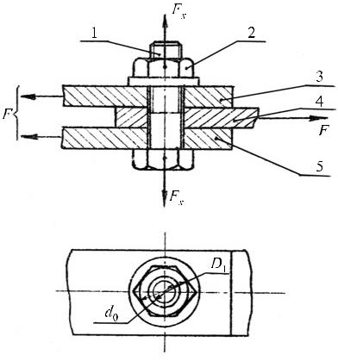
S_{σT} – the strength reserve factor (the safety factor);
T_{už} – the screw or the nut tightening torque;
T_{sr} – the thread tightening torque;
T_{d} – the moment of friction between the nut and the element;
d₂ – the pitch diameter of thread;
β - the thread helix angle;
f_{d} – the friction coefficient between the nut and the element;
D₁ – the major diameter of the nut bearing surface equal to the size of the nut wrench;
d₀ – the minor diameter of the nut bearing surface equal to the diameter of the hole for the screw;
q‘ – the reduced friction angle;
f‘– the reduced friction coefficient;
f – friction coefficient of a thread;
σ_{T,} – the yield strength of the material of the screw;
d₁ – the minor diameter of thread.
LOADS OF SCREW JOINTS
In mechanical engineering, screw thread elements as detachable joints are widely used. Frequently, the bolts used for a joint are placed in such a way that an external load acts in the direction perpendicular to the axis of a bolt. In such a case, two versions of the structure of the connection are possible – with bolts inserted in exactly matched holes and with bolts inserted in holes of a larger diameter. In this laboratory works, the latter version of joining shall be studied. When elements 3, 4 and 5 are joined by the bolt (Fig. 1.1) and the nut 2 and a clearance exists between a bolt and an element, the joint is considered reliable, if elements cannot shift (change their positions) with respect to each other. This condition is satisfied, when the friction force in the zone of contact that appears on clamping the bolt by the force F_{x} counterbalances the external displacing force F.
Fig. 1.1. A screw joint loaded by a transversal force

The element 4 will not displace, when
F ≤ F_{x} f_{s}i; (1.1)

here f_{s} – the friction coefficient in the joint; i – the number of contacting pairs of planes.
Using the formula (1.1), we can calculate the required bolt clamping force. In should not exceed the allowable value of F_{x, adm} from the condition for tension strength of the bolt:
$F_{x,adm}≤\frac{{πd}_{1}^{2}}{4}×\frac{σ_{t,adm}}{1,3}$ (1.2)
here d₂ – the minor diameter of thread; σ_{x, adm} – the allowable tension stresses of the material of the bolt:
$$σ_{t,adm}=\frac{σ_{T}}{S_{σT}};$$
here σ_{T,} – the yield limit of the material of the bolt; S_{σT} – the strength reserve factor (the safety factor).
In this work, the required fastening force is created on tightening the nut.
The tightening torque:
T_{už} = T_{sr} + T_{d};
here T_{sr} – the thread tightening torque; T_{d} – the moment of friction between the nut and the element.
Because
$T_{sr}=F_{x}\frac{d_{2}}{2}tg(β+q^{'})$, ir
$$T_{d}=F_{x}f_{d}\frac{D_{1}+d_{0}}{4}$$
then
$$T_{už}=F_{x}\left[\frac{d_{2}}{2}tg\left(β+q^{'}\right)+f_{d}\frac{D_{1}+d_{0}}{4}\right];\text{ (1.3)}$$
here d₂ – the pitch diameter of thread; β - the thread helix angle; f_{d} – the friction coefficient between the nut and the element; D₁ – the major diameter of the nut bearing surface equal to the size of the nut wrench; d₀ – the minor diameter of the nut bearing surface equal to the diameter of the hole for the screw; q‘ – the reduced friction angle.
q ' = arctg f ‘ ;
here f‘– the reduced friction coefficient;
$$f^{'}=\frac{f}{cos\frac{α}{2}}$$
f_{s} – the friction coefficient in the thread.
In the metric system, the thread profile angle α = 60º, so
$$f^{'}=\frac{f}{cos30°}≈1,15f$$
Upon applying the formulas (1.1) and (1.3), we obtain the following expression of the displacing force:
$$F=\frac{f_{s}∙i}{\frac{d_{2}}{2}tg\left(β+q^{'}\right)+\frac{D_{1}+d_{0}}{4}f_{d}}T_{už}\text{ (1.4)}$$
As it may be seen from the formula (1.4), the force F will depend not only on T_{už} , but also on other parameters; however, it is almost impossible to establish their values. So, the dependence of F on F_{x} will be established in an experimental way.

Aim of the work

To establish the dependence of the force displacing the joined elements on the fastening force of the threaded joint for different degrees of roughness of the joined elements and the thread of the screw.

Description of the structure of the work-bench

The work-bench DM-23 M (Fig. 1.2) consists of the base 1, two supporting slabs 3 and 11, two plates 4, the bolt 6 with the nut 10, bushings 7 and 9, the slide 5 with the support 8. The supporting slabs are connected with the axle 2 of the base and fixed by the plate 12. The slope of the bushing prevents rotation of the bolt while fastening the nut. Special marks on the slide and the plates enable observing possible displacements. At the initial moment, the mark on the slide coincides with the upper mark on the panels. The threaded joint is fastened by a dynamometric wrench.
In the works, panels of three degrees of the surface roughness may be used with the slide.
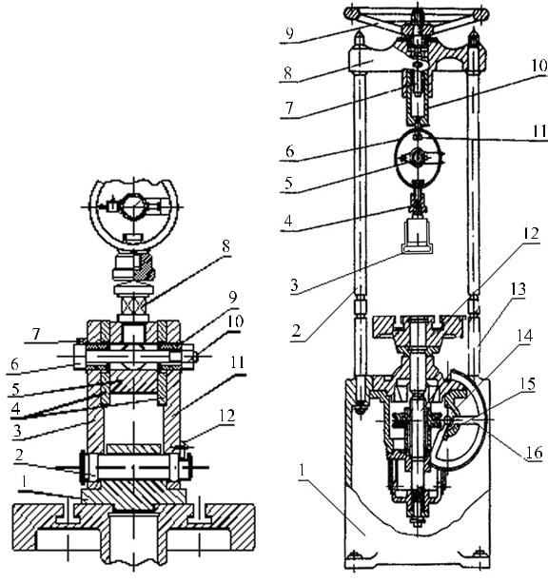
The force displacing the joined elements is created by the screw press DM-30 M (Fig. 1.3). The slide through the screw is connected to the dynamometric ring with the indicator 5 fixed in it. From the readings of the indicators, the value of the force acting the screw joint may be concluded.
Fig. 1.2. The scheme of the device DM-23 M
Procedure of the work

- Take the couple of a bolt and a nut, the slide and the plates specified by the university teacher.
- Measure the diameter d₀ in the washer of the hole and the major diameter of the bearing surface of the nut D₁.
- According to the formula (1.2), calculate the allowable screw joint fastening force F_{x,adm} upon considering that the yield strength σ_{T,} = 350 MPa and S_{σT} = 1.5.
- According to the formula (1.3), calculate the tightening torque T_{už} that corresponds to the fastening force F_{x} not exceeding F_{x,adm} calculated according to the formula (1.2). Choose the thread helix angle β and the pitch diameter of thread d₂ from the Table 1. Consider the coefficient of friction in the thread f_{s} and the friction coefficient between the nut and the element f_{d} equal to 0.15.
- According to the formula (1.4), calculate the displacing force F that corresponds to different values of the tightening torque: 0.2 T_{už} ; 0.4 T_{už} ; 0.6 T_{už} ; 0.8 T_{už} ; and T_{už} . According to the results of the calculation, draw the curve of dependence of F on T_{už} .
- According to the Fig. 1.2, assembly the screw joint on the work-bench.
- Fasten the joint by the dynamometric wrench using the torque 0.2 T_{už} .

Table 1. The parameters of threads
Major diameter of the thread  (mm)~d₀ | Pitch  (mm) | Pitch diameter of the thread  (mm) d₂ | Minor diameter of the thread  (mm) d₁ | Thread helix angle  (°) β
 | 1.5 | 9.026 | 8.376 | 4.037
10 | 1.25 | 9.188 | 8.647 | 2.511
 | 1 | 9.350 | 8.918 | 1.951
 | 1.75 | 10.863 | 10.106 | 2.937
12 | 1.5 | 11.026 | 10.376 | 2.481
 | 1 | 11.350 | 10.918 | 1.607
 | 2 | 12.701 | 11.835 | 2.871
14 | 1.5 | 13.026 | 12.376 | 2.128
 | 1 | 13.350 | 12.918 | 1.367
 | 2 | 14.701 | 13.835 | 2.480
16 | 1.5 | 15.026 | 14.376 | 1.820
 | 1 | 15.350 | 14.918 | 1.188
 | 2.5 | 16.376 | 15.350 | 2.782
18 | 1.5 | 17.026 | 16.376 | 1.606
 | 1 | 17.350 | 16.918 | 1.051
 | 2.5 | 18.376 | 17.350 | 2.480
20 | 1.5 | 19.026 | 18.376 | 1.438
 | 1 | 19.350 | 18.918 | 0.942

- Put the device on the table of the press DM-30 M.
- Load gradually the screw joint, until the slide will displace in respect of the slabs. The beginning of the displacement is shown by a jump of the needle of indicator of the dynamometric ring (the displacement does not increase the force). The maximum reading of the indicator conforms to the friction of rest. Upon using the specified graphical value of the calibration constant for the dynamometric ring, establish the factual value of the displacing force.
- According to provisions of the Paragraph 9, establish the factual value of the displacing force at the following values of the tightening torque: 0.4 T_{už} ; 0.6 T_{už} ; 0.8 T_{už} ; and T_{už} . It should be observed whether the mark on the slide is not under the lower mark on the slab, because that shows that a clearance between the slide and the bolt does not exist anymore, i.e. the latter is being bent already.
- Fix the values of F obtained during the experiment. Form the curve of dependence of F on T_{už} and compare it with the dependence calculated in the Paragraph 5.
- Formulate the conclusions; explain the differences between the results of the calculation and the experiment.

Report of 1 laboratory work
THE STUDY OF A SCREW JOINT LOADED WITH A TRANSVERSAL FORCE

- Measurement of screw joint parameters.

Parameters of screw joint were measured using a caliper, which has a minimum scale step of :.....................mm
Minor diameter of the nut bearing surface d₀ = ..........................mm.
Major diameter of the nut bearing surface D₁= ..........................mm.
Pitch screw threadline =.....................mm.

- Thread parameters taken from table 1:

Pitch diameter d₂=.....................mm.
Minor thread diameter d₁=.....................mm.
Thread helix angle β=.....................°

- Calculation of ultimate screw joint clamping force.

Ultimate stress of the screw material:
$$σ_{t,adm}=\frac{σ_{T}}{S_{σT}}=$$
Ultimate screw joint clamping force:
$$F_{x,adm}=\frac{{πd}_{1}^{2}}{4}×\frac{σ_{t,adm}}{1,3}=$$

- Calculation of clamping force.

Friction coefficient equal to:
f=f_{d}=f_{s}=
Reduced friction coefficient:
$$f^{'}=\frac{f}{cos\frac{α}{2}}=$$
Reduced friction angle:
$$q^{'}=arctg f‘=$$
Screw or nut tightening torque:
$$T_{už}=F_{x}\left[\frac{d_{2}}{2}tg\left(β+q^{'}\right)+f_{d}\frac{D_{1}+d_{0}}{4}\right]=$$

- Calculation of displacement force.
$$F=\frac{f_{s}∙i}{\left[\frac{d_{2}}{2}tg\left(β+q^{'}\right)+\frac{D_{1}+d_{0}}{4}f_{d}\right]}∙T_{už}=$$

- The dependence of the displacing force on the tightening torque.
Values of tightening torque (Nm) | Displacement force F (N) (1 step = 500N)
 | calculated | eksperimentinė
 |  | Indicator readings of the dynamometric ring on the work bench(mm) | Value of the force according to calibration curve (N)
0,2 T_{už}=
0,4 T_{už}=
0,6 T_{už}=
0,8 T_{už}=
T_{už}=

- Graphs of calculated and experimental force dependancies F=(T_{už}).

- Conclusions:

Work done by:

Work accepted by:

3 Laboratory work

THE STUDY OF A BELT DRIVE

The abbreviations and their meanings:

α - the pulley-wrap angle;
E – the modulus of elasticity of the belt;
F₀ – the initial belt tension force;
A – cross-section area of the belt;
δ – stresses in the belt caused by the initial tension force (for V-belts – 1.2 ÷ 1.5 MPa; for flat belts - 1.5 ÷ 1.8 MPa);
δ_{b} – the maximum stresses in the belt;
δ_{t} – the useful stress of the belt;
δ ₀ – the stresses in the belt caused by the initial tension force
φ– the pull factor of the drive;
φ₀ – the value of the pull factor of the drive that conforms to the maximum value of the coefficient of efficiency;
φ_{max –} maximum value of drive load.
F₀ – initial belt tension force.
F₁ – the belt tension force in the first side;
F₂ – the belt tension force in the second side;
F_{t} – the useful force transmitted by the belt;
T₁ – the torque of the drive shaft;
T₂ – the torque of the driven shaft;
d₁ – the diameter of the driving pulley;
d₂ – the diameter of the driven pulley;
n₁ – the rotational frequency of the first pulley;
n₂ – the rotational frequency of the second pulley;
V₁ – the angular velocity of the first pulley;
V₂ – the angular velocity of the second pulley;
ξ – slide coefficient of the drive.
η– the coefficient of efficiency of the drive.
BELT DRIVES AND THEIR PECULIARITIES
Types of belts

Belt drives are included in the group of friction drives. Materials of the belts should be strong, elastic and insensitive to environmental impact; in addition, the coefficient of friction between a belt and a pulley should be high. A single material cannot meet all the said requirements. At present, leathern, woven and multi-woven belts are most widely used.
Leather belts. They distinguish themselves for a high coefficient of friction between the belt and the material of the pulley; in addition, they are strong and flexible enough. Leather belts operate well while affected by permanent and variable loads; their edges are resistant to destruction. However, these belts are costly, so, in spite of the above-mentioned advantages, they are used rarely.
Woven belts. The principal part of such belts is textile. The belts may be woven of organic or synthetic materials. The first group includes cotton, animal wool, hemp, flax and natural silk; the second group included rayon as well as polyamide, polyethylene and nylon fibers, also foam polyurethane.
Multi-layer belts. They are most perfect flat belts. Usually, such a belt consists of three layers intended for different functions; they include a friction layer, a pull layer and a protective layer. The friction layer is formed of chromed leather, rubber or elastomer, the pull layer – of polyamide strips or polyester yarn with cord. The function of the protective layer is performed by a textile or an elastomer foil. Such belts distinguish themselves for high pull force and good cohesion with the pulley.
V-belt sets. They are made of trapezoidal cross-section strips with their ends joined by special staples. Such belts are produced of polymers armored with cord strips. These belts are less flexible, as compared to endless belts; however, their insertion between the pulleys and removal is considerably simpler, because the distance between the pulleys should not be changed.
Endless belts are free of joints. They are produced of fixed lengths, so a user cannot change them. Their principal parts include cord yarn, polymer filling and impregnated cover.
Tooth belts are flat belts with teeth. They transmit a load or a motion through a toothed pulley. Drives of this type transmit higher powers and cause lowers loads on shafts and bearings; their belts do not slip, do not require additional stretching during the operation and their operation is silent. They are usable in machines, engines and so on.
The cross-section of flat belts is rectangular, of V-belts – trapezoid, of round – round and polytrapezoid. According to the shape of the belt’s cross-section, belt drives are divided to flat, trapezoid, round and polytrapezoid ones.
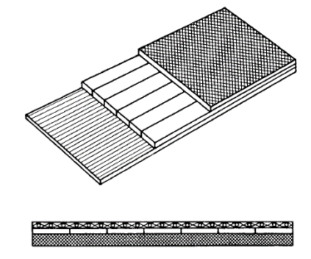
A flat belt
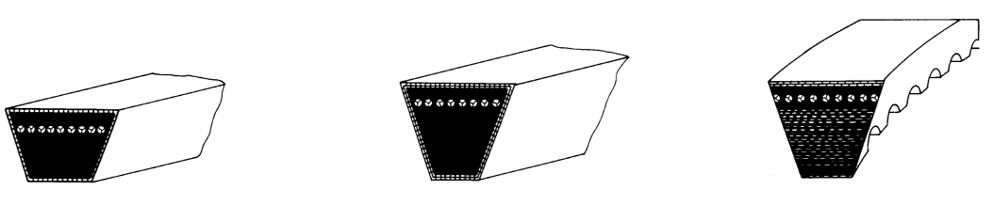
A V-belt (trapezoid) belt
A polytrapezoid belt
Belt drive pulleys

The pulleys should be strong, light and balanced. To ensure less attrition of a belt, its working surface should be smooth. Pulleys are produced of grey cast iron, steel, light alloys and polymers. A pulley consists of a rim, a hub and a disc or spokes that connect the rim with the hub.
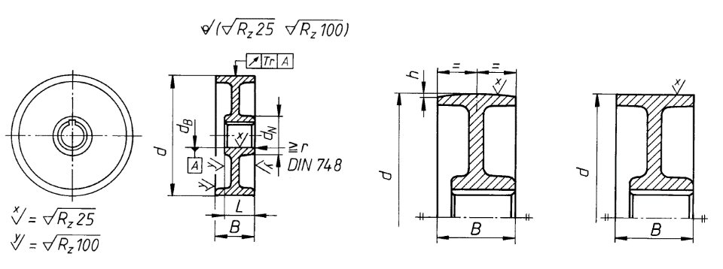

Pulley of flat belt drives.

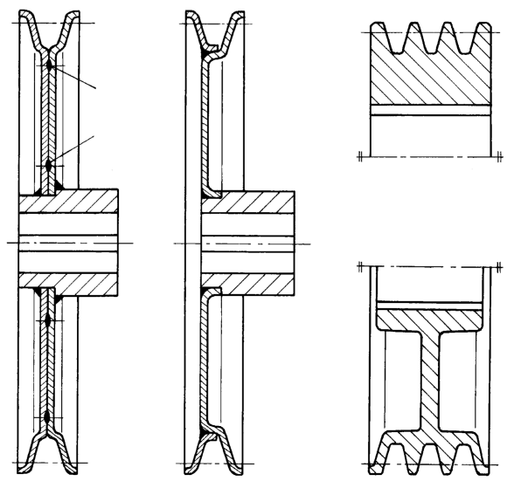
A rim of a belt drive’s pulley with a single groove.
It may have three grooves, too.
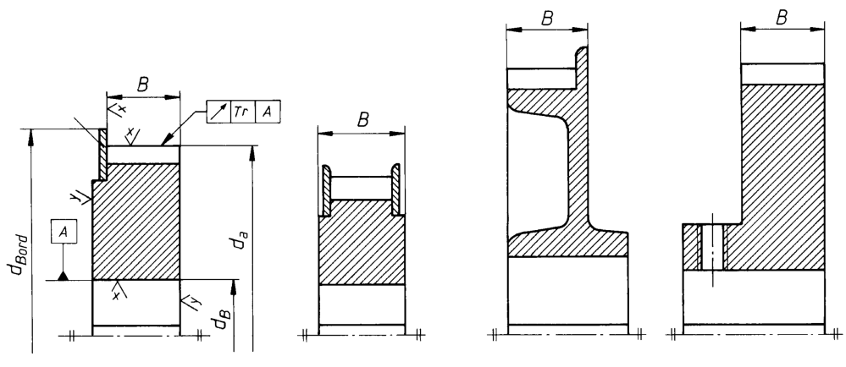Pulleys of toothed belt drives

The requirements set for pulleys of V-belt drives and structures of them are the same, as for pulleys of flat belt drives. Toothed pulleys are usually produced of light alloys and thermoplastics, more rarely – of steel or grey cast iron. In serial production, they are produced by pressure-die casting. To avoid falling of the belt from the pulley, special ribs are provided.
The useful force F_{t} that may be transmitted by the belt depends on the coefficient of friction, the elastic sliding angle and the initial belt tension force.
The coefficient of friction depends on frictional properties of the materials used for the belt and the pulley. The value of the elastic slippage angle depends on the pulley-wrap angle (the arc of contact) and the modulus of elasticity of the belt E. The initial belt tension force depends on the strength of the belt and the loading rating of bearings. This force may be expressed as follows:

$2F_{0}=2Aδ_{0}$ (3.1)
here: – the area of the belt’s cross-section; – the stresses in the belt caused by the initial tension force. Their values are: for V-belts – 1.2-1.5 MPa; for flat belts – 1.5-1.8 MPa.

Fig. 3.1. The scheme of a belt drive

It may be seen from the Fig. 3.1. that in absence of a load, i.e. when T_{1,2} = 0, the tension forces of the sides of the belt are the same:

F₁=F₂=F₀ or F₁+F₂=2F₀ (3.2)

On transmission of the torque, dependently on the direction of rotation, one side of the belt is affected by an increased tension force F₁ and is called the active side, whereas the other side of the belt is affected by a decreased tension force F₂ and is called the passive side. The difference between the said forces is the useful force transmitted by the belt:

$$F_{1}-F_{2}=F_{t}=\frac{2T_{1}}{d_{1}} \text{(3.3)}$$

From the equations (3.2) and (3.3), the values of F₁ and F₂ may be found:
$$F_{1}=F_{0}+\frac{F_{t}}{2} \text{and} F_{2}=F_{0}-\frac{F_{t}}{2} \text{(3.4)}$$
It may be concluded that the larger initial tension force, the bigger possible difference between forces of the side tension, also the larger useful transmitted belt tension force or the transmitted torque. However, the tension force F₀ cannot be boundlessly increased, because during the operation the tension of the active side can exceed the ultimate stresses (δ₀ + δ_{t} > δ_{b}) and the belt can break.
When the belt transmits the torque there an elastic slippage inevitably occurs between the belt and the pulleys. It results in different angular velocities of the pulleys. Their difference is expressed by the coefficient of sliding:
$$ξ=\frac{V_{1}-V_{2}}{V_{1}}∙100\%$$
If we substitute the velocities V₁ and V₂ by rotational frequencies:
$$V_{1}=\frac{πd_{1}n_{1}}{60} \text{and} V_{2}\frac{πd_{2}n_{2}}{60}$$
when d₁ = d₂, we obtain:
$$ξ=\frac{n_{1}-n_{2}}{n_{1}}=\left(1-\frac{n_{2}}{n_{1}}\right)∙100\% \text{(3.5)}$$
Sliding inevitably changes the efficiency:
$$η=\frac{T_{2}∙n_{2}}{T_{1}∙n_{1}}∙100\% \text{(3.6)}$$
It is almost impossible to calculate mathematically the changes of the coefficient of slipping and the efficiency of various loading, because it depends on many factors which cannot always be described. That is why belt drives are being investigated experimentally. The results of the experiments are shown in curves when the pull factor is laid off as abscissas:
$$φ=\frac{F_{t}}{2F_{0}}=\frac{2T_{1}}{d_{1}2F_{0}}=\frac{T_{1}}{d_{1}F_{0}} \text{(3.7)}$$
And the coefficient of slipping ξ and the coefficient of efficiency is laid off on the axis of coordinates expressed in percent as shown in Fig. 3.2.

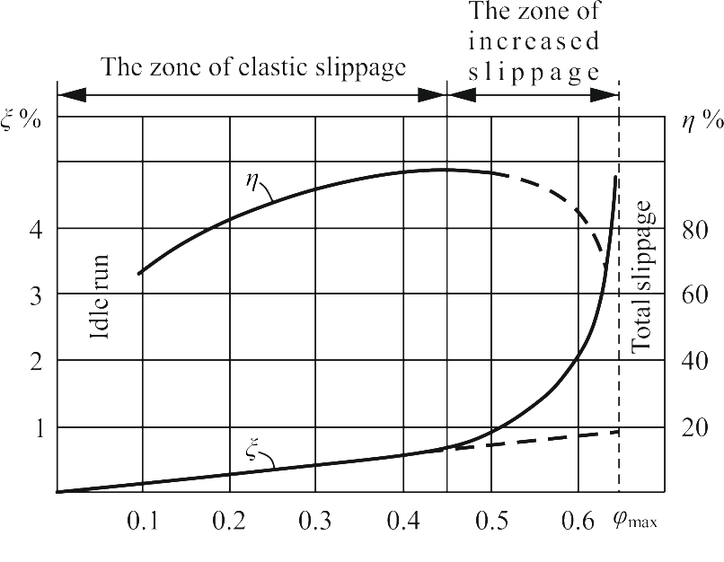
Fig. 3.2. The changes of the coefficients of slippage and efficiency under loading

The serviceability of a belt drive is characterized by the curves of the changes of slippage and efficiency. Two characteristic zones are noticed before overloading, i.e. the total slippage:
– the zone of elastic slippage (creep) where the values of φ vary from 0 to φ₀;
– the zone of increased slippage where the values of φ vary from φ₀ to φ_{max}.

Slipping of an elastic belt depends on its elastic deformations. Because elastic deformations of a belt almost correspond to Hookes law, this part of the slippage curve is close to a straight line. In this zone, the coefficient of efficiency approaches its maximum value.
In this zone, a belt drive should not operate constantly. Small overloads are allowed for a short time only.
Thus, the slippage and efficiency curves enable to find not only the optimal ratio (3.7) of the useful and the initial tension forces of the belt but also the probability that short overloading is not harmful to a belt drive. This probability should not exceed the following limits:

Types of belts
V-belts | 1.5 – 1.6
Flat belts | 1.25 – 1.4
Flat rubber belts | 1.15 – 1.3
Flat leathern and woolen belts | 1.35 – 1.5

Aims of the work

- To calculate the total strength 2F₀ of the initial tension of the belt.
- To determine the torque T₁ which can be transmitted.
- To determine the coefficient of efficiency and the coefficient of slippage ξ that corresponds to it.
- To show the results graphically and formulate the conclusions on serviceability of the drive.
Structure description of the work bench
The work bench is assigned for investigation of a V-belt drive or a flat belt drive, so its principal part is a belt drive.
The driving pulley 7 of the drive is pressed on the shaft of the balanced electric engine. The body of the balanced electric engine may oscillate axially. The driven pulley 12 is pressed onto the brake shaft. For facilitation of the processing of the results of the experiment, the diameters of both pulleys are the same (d₁ = d₂).

Fig. 3.3. Work bench for a belt drive study

By means of the adjusting screw 14 it is possible to change the pressing force of the blocks of the brake onto the drum of the brake; in this way, different braking torques T₂ are obtained.
Reactive torque T₁ of the balanced engine and the braking torque T₂ are measured by the deformations of the flat springs. The ends of the said springs are fastened in the arms 5 and 15. They are bent by the engine stator and the brake body which tend to turn. Clock-type indicators 13 are fastened in the spring arms. Spring bending is measured by them. The scale of the indicators is 0.01 mm. The springs are calibrated. T₁ and T₂ are determined from the calibration curves.
The torques T₁ and T₂ may be determined by strain measuring. Wire resistivity transducers are glued onto the measuring springs. Transducers are calibrated according to the same bendings of the springs and joined to clamps 16.
Rotational velocities of the pulleys are measured by the pulse transducers equipped at the opposite ends of the shafts. Their pulses are transmitted to revolution counters 8 and 9 (8 – of the driving shaft; 9 – of the driven shaft). The pulse transducers are also joined to the clamps 17.
Measuring signals of the clamps 16 and 17 may be transmitted to other measuring and recording devices, such as oscillographs, recorders, computers, etc.
The belt 6 is tensioned by a lever device 2, 3, 4. The tension force is changed by the weight 1. The engine is turned on and off by the switch 18.
By the three-position close 10, it is possible to join the pulse transducers with counters 8 and 9 or with the clamps 17 or switch them off.

Procedure of the work

- Make sure that the brake is free.
- Calculate the necessary initial tension force according to he equation (3.1).
- Load the lever 2 with the weights 1. As the ratio of the lever arms u = 5, so the load G = 0.041 A δ₀ (kgF).
- Make sure that the counters are switched off and set them to the zero position.
- Start up the engine and load gradually (with a 0.1 mm step shown by the indicator) the drive by turning the brake handle 14. In each step of loading (their number should be about
6 to 8):
– switch on the counters for 10-20 seconds;
– record the number of revolutions of the driving shaft and the driven shaft and calculate their rotating frequency (rpm).
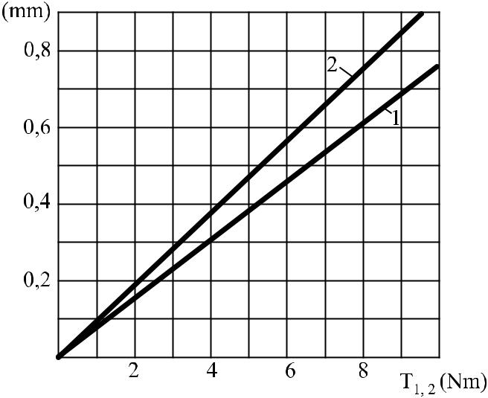
- Record the readings of the engine and brake indicators and find the torque T₁ of the engine and the torque T₂ of the brake from the calibration curves (1 – for the engine; 2 – for the brake). (Fig. 3.4)
Fig. 3.4. Calibration curves of the engine (1) and brake (2) springs.

- According to the equation 3.5, calculate the coefficient of slippage ξ for each step of loading.
- According to the equation 3.6, calculate the coefficient of efficiency η for each step of loading.
- Calculate the values of the pull factor φ.
- . Draw the curves of the coefficient of slippage and the coefficient of efficiency.
- Provide your conclusions about the investigated drive.

Report of 3 laboratory work
THE STUDY OF THE BELT DRIVE

- Drive data:
Type of belt (flat, trapezoid, polytrapezoid).
Cross-section area of the belt A=............................mm².
Drive pulley diameters d₁ = d₂ = ...................mm.
Indicator measuring time t = ...........................s

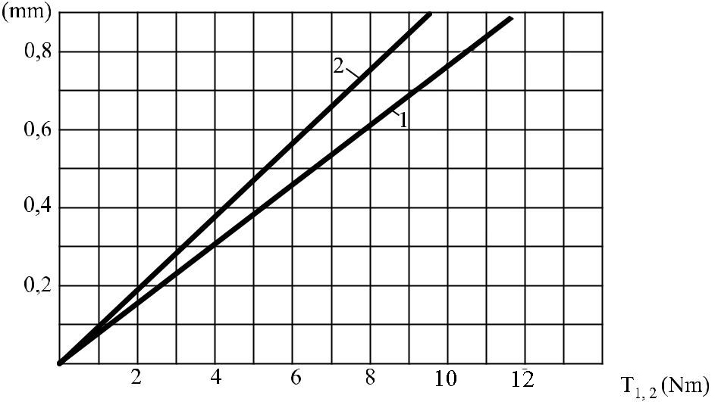
- Calibration curves of the engine (1) and brake (2) springs:

- Results of the experiment:

Reading no. | Values of motor indicator (mm) | Values of break indicator (mm) | Momentum of driving shaft T₁ (Nm) | Momentum of driven shaft T₂ (Nm) | Motor revolutions per time t (s) | Break shaft revolutions per time t (s) | Driving shaft rotational frequency n₁ (RPM) | Driven shaft rotational frequency n₂ (RPM) | Sliding coefficient  ξ (%) | Efficiency coefficient η (%) | Pull coefficient  φ
1 |  | 0,1
2 |  | 0,2
3 |  | 0,3
4 |  | 0,4
5 |  | 0,5
6 |  | 0,6

- Graphs ξ= f(φ) ir η = f(φ).
ξ= f(φ)
η = f(φ)

- Conclusions:

Work done by:

Workd accepted by:

LABORATORY WORK 5
THE STUDY OF A CYLINDRICAL SPUR REDUCTOR

Abbreviations and their meanings

g – free fall acceleration (gravity factor) of a body;
F₁ – the weight of the plummet;
F₂ – the weight of the plummet;
m₁ – the mass of the plummet;
m₂ – the mass of the plummet;
h_{ti-1} – the earlier value of the indicator’s reading;
h_{ti} – the indicator’s reading;
ΔT₁ – the increase of the torque created by the plummet on the shaft of the engine;
ΔT₂ – the increase of the torque created by the plummet on the shaft of the magnetic powder brake;
k_{ti} – the calibration constant for a specific range;
k_{1i} – the calibration constant;
k_{2i} – the calibration constant;
k₁ – the arithmetic average of the calibration constants;
k₂ – the arithmetic average of the calibration constants;
n – the number of measurements;
h₁ – the reading of the indicator fixed to the engine;
h₂ – the reading of the indicator fixed to the magnetic powder brake;
ω₁ – the angular speed of the driving shaft;
ω₂ – the angular speed of the driven shaft;
P₁ – the consumed power;
P₂ – the received power;
T₁ – the torque of the driving shaft;
T₂ – the torque of the driven shaft;
U – the total reduction rate;
η - the efficiency factor of the drive
CYLINDRICAL REDUCTORS
In machine building, mechanical drives are most frequently used for reducing the rotational frequency and simultaneously for increasing the torque. One or several mechanical drives located in the same housing and usable for reducing the rotational frequency are referred to as a reductor. In manufacture of devices, mechanisms having the opposite properties (multipliers) are frequently used. In production of vehicles, reductors are used for achieving a higher torque of the wheels; however, they are referred as demultipliers in this case.
In reductors, various drives (such as toothed drives with spur or helical teeth, chevron and conical drives as well as worm drives), are usually used, because their sizes are small, so their mounting in the common housing is easy. Still less sizes of reductors are obtained, if planetary and wave drives are used.
Gear reductors formed of cylindrical gears where the drives are located in series one after another are referred to as cylindrical reductors. The high-speed shaft of a reductor is called the initial shaft and the low-speed shaft of it is called the end shaft. Any other shafts between the initial shaft and the end shaft are referred to as interim shafts. In the direction of deceleration of rotation, the interim shafts are named the first interim shaft, the second interim shaft and so on. According to the number of drives, reductors are classified to single-stage reductors (with a single drive), two-stage reductors (with two drives) and so on. In this laboratory work, a multi-stage cylindrical spur reductor shall be studied and experimentally worked.
The total reduction rate u of the reductor under the work is equal to the product of the reduction rates of its stages:
U=u₁∙u₂∙.....∙u_{n}; (5.1)
Here $u_{1}=\frac{z_{2}}{z_{1}}$.
If the reduction rate of a mechanism is constant, the efficiency factor of such a mechanism, as it is known from the Theory of Mechanisms and Machines, may be conveniently found from the ratio of the consumed power and received power:
$$η=\frac{P_{2}}{P_{1}}=\frac{T_{2}ω_{2}}{T_{1}ω_{1}}=\frac{T_{2}}{T_{1}U} \text{ (5.2)}$$
The torque of the initial shaft T₁ and the torque of the end shaft T₂ shall be found in an experimental way.

Aim of the work
- To get to know the operation of a multi-stage cylindrical spur reductor.
- To learn establish the kinetic parameters on visual observance of the mechanism.
- To draw a kinetic scheme of the reductor.
- To find the reduction rates of stages of the reductor and the total reduction rate of the reductor.
- To introduce to calibration of devices.
- To establish the dependence of the efficiency factor of the reductor on various modes of operation.

Description of the structure of the laboratory bench

The laboratory bench presented in Fig. 5.1 consists of the following components: the reductor under research 5, the electric engine 5 with the mechanical tachometer 1, the loading equipment 6 and the torque measuring devices 8 and 9. All of them are mounted in the mounting rack 7. The stator of the engine is fixed by hinges in two supports in a way that ensures a coincidence of its axis of rotation with the rotor’s axis of rotation. The plane spring 4 prevents the stator from rotation. In addition, it withstands the torque reaction (that affects the stator) equal to the rotor’s torque. The rotor’s shaft is connected to the initial shaft of the reductor 5 by a coupling. The other end of the shaft is connected to the shaft of the mechanical tachometer 1. The lever 10 is used for calibration of the device for measuring the torque that affects the stator. The plummet put on the lever creates a torque of the desirable value that simulates the above-mentioned torque of the stator’s reaction.
The reductor 5 consists of the housing and toothed drives connected with each other in series. The housing is covered with a transparent hood that enables observing the operation of the reductor.
The loading device 6 is a magnetic powder brake. Its structure is shown in Fig. 5.2. Operation of the brake is based on resistance of a ferromagnetic fluid to motion of bodies while electromagnetic field crosses the fluid. A ferromagnetic fluid is an oil (one weight fraction of industrial oil Shell Omala 150, DIN 51517) that includes grains of carbonyl iron (6 weight fractions, the mark R-10 GOST 13610-79). In Fig. 5.3 a, the gap q filled with the ferromagnetic fluid is shown. The gap is formed by surfaces of the magnetic details 8, 11 and 13 (Fig. 5.2). Usually, the powder evenly spreads in the gap. While affected by a magnetic field, the grains form “filaments” along the lines of the magnetic field. The grains lock into each other and the filaments adhere to the surfaces that form the gap. When the surfaces move, a force resisting to the said movement appears. The value of the said force depends on the strength of magnetic field. If the magnetic field is generated by an electromagnet, the said resisting force can be controlled by changing the current in the windings 12 (Fig. .2). The body of the loading device 6 with the yoke 8 and the kingpin 11 of the electromagnet may rotate in two bearings 2 mounted in the mounting rack 7. Its axis of rotation coincides with the axis of rotation of the drum 13. The shaft 4 of the drum is connected to the end shaft of the reductor by a coupling. The drum 13 rotates in the gap between the kingpin 11 and the yoke 8 of the electromagnet. The ferromagnetic fluid is poured into the brake through the funnel 10, then flows through channels B and fills the active gap of the electromagnet where the drum 13 rotates. The fluid that permeates through the gland 5 gets into the cavity A. The plug 7 is used for controlling the fluid and the plug 14 – for its outpouring. The felt 16 protects the bearings of the shaft 4 against the ferromagnetic fluid that gets into the cavity A. The torques of the engine and the brake are measured by the plane springs 4. They prevent the body of the engine and the brake from rotation. On the springs, resistance sensors are glued. The sensors are connected to the input circuit of the tensor amplifier. Thus, the deflections of the springs are assessed according to the readings of the indicators 8 and 9. The rotational frequency of the engine is measured by an mechanical tachometer.

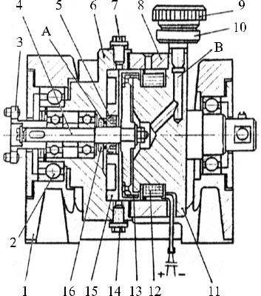
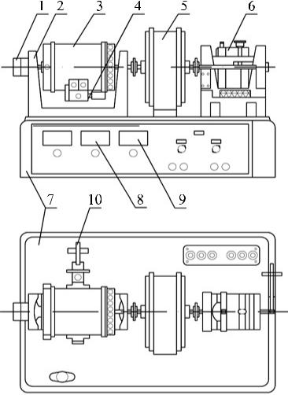
Fig. 5.1. The bench for working a cylindrical reductor

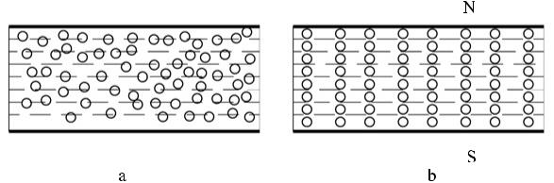
Fig. 5.2. A magnetic powder brake.
Fig. 5.3. The gap filled with the ferromagnetic fluid:
a – in absence of magnetic field; b – upon an impact of magnetic field

Procedure of the work
- After examination of the structure of the reductor, draw a kinematic scheme.
- Establish the reduction rates of the stages of the reductor and calculate the total reduction rate u of the reductor according to the equation 5.1.
- Calibrate the indicator for the engine torque measuring as follows:
  - Fix a bar to the stator’s tang.
  - Put the plummet at the zero scale division of the bar and write down the reading of the indicator in the Table 5.1.
  - Push the plummet on the bar to new positions 3, 6, 9, 12 and 15 cm and fix the relevant readings of the indicator in the Table 5.1.
  - Calculate the calibration constant for each range:
$$k_{1i}=\frac{{∆T}_{i}}{h_{1i}-h_{1i-1}}\text{; (5.3)}$$
here: h_{1i} – the reading of the indicator when the plummet is in the position i; h_{1i−1} – the previous reading of the indicator when the arm of the plummet was 3 cm shorter; ΔT₁ - the increase of the torque created by the plummet when the arm increases by 3 cm.
The mass of the plummet m₁ = 0.1 kg.
Its weight F₁=m₁ ∙ g=0.1∙9,81=0,981N,
ΔT₁ = m₁ ⋅ g ⋅Δl₁ = 0,1⋅ 9,81⋅ 0,03 = 2,943 ⋅10⁻² Nm.
Fill in the results in Table 1.

  - Find the arithmetic average of the calibration constants k_{1i} - it shows the torque of the engine that corresponds to one scale division of the indicator:
$$k_{1vid}=\frac{Σk_{1i}}{n} \left[{Nm}/{mm}\right]\text{; (5.4)}$$
here: n – the number of measurements.
  - Calculate corresponding torque values according to formula T₁=k_{1vid}∙h₁ and fill in the table 5.1.
  - Draw the calibration curve h₁ = f(T₁).
- Calibrate the indicator for measuring the braking torque as follows:
  - Fix a bar to the body of the brake.
  - Put the plummet at the zero scale division of the bar and write down the reading h₂ of the indicator in the Table 5.2.
  - Push the plummet on the bar to new positions 4, 8, 12, 16 and 20 cm and fix the relevant readings of the indicator in the Table 5.2.
  - Calculate the calibration constant for each range:
$$k_{2i}=\frac{{∆T}_{2}}{h_{2i}-h_{2i-1}}\text{; (5.5)}$$
here: h_{2i} – the reading of the indicator when the plummet is in the position h (rpm); h_{2i-1} – the previous reading of the indicator when the arm of the plummet was 4 cm shorter; ΔT₂ - the increase of the torque created by the plummet when the arm increases by 4 cm.
The mass of the plummet m₂ = 1,0 kg.
Its weight F₂ = m₂ · g = 9,81 N.
Then ΔT₂ = m₂ ⋅ g ⋅ Δl₂= 1⋅ 9,81⋅ 0,04 = 0,392 Nm.
Fill in the results in Table 5.2.
  - Find the arithmetic average of the calibration constants k₂ - it shows the braking torque that corresponds to one scale division of the indicator:
$$k_{2vid}=\frac{{Σk}_{2i}}{n} \left[{Nm}/{mm}\right];$$
here: n – the number of measurements.
  - Calculate corresponding torque values according to formula T₂=k_{2vid}∙h₂ and fill in the table 5.2.
  - Draw the calibration curve h₂ = f(T₂).

- Establish the dependence of the efficiency factor on the load.
  - Switch on the engine. Set one of the following rotational frequencies according to your data sheet values:
- n₁ = 600 rpm;
- n₂ = 800 rpm;
- n₃ = 1000 rpm;
- n₄ = 1200 rpm;
- n₅ = 1400 rpm;
Attention. During the experiment, observe whether the value of n₁ is constant. If it changes, adjust it.
  - Increase the braking torque by the magnetic power brake (with a step of 0.5 mm), thus causing varying on the load of the reductor. The values of the torque are shown by the indicator fixed to the brake. Fix the found values of h₁ and h₂ in the Table 5.3.
  - Establish the torques T₁ and T₂ from the calibration curves of the values of h₁ and h₂ found in the paragraphs 3.7 and 4.7 and fill them in the Table 5.3.
  - Using the equation 5.2, find the efficiency factor for each case of T₁ and T₂. Fix the results in the Table 5.3.
- Establish the dependence of the efficiency factor on the rotational frequency: η = f (n₁).
  - According to the schedule of works, set one value of the following values of the torque T₂:
  - T₂ = 1.0 Nm;
  - T₂ = 1.2 Nm;
  - T₂ = 1.4 Nm;
  - T₂ = 1.6 Nm;
  - T₂ = 1.8 Nm;
Attention. During the experiment, observe whether the value of T₂ is constant. If it changes, adjust it.
  - Upon varying the feeding current of the obtain various values of the rotational frequency n₁. Starting from the lowest value and increasing it by 200 RPM each step. Fill them and the values h₁ of the engine torque shown by the indicator in the Table 5.4.

  - From the calibration curve h₁ obtained in the paragraph 3.7, find values of T₁ for the values of h₁ and fix them in the Table 5.4.Using the equation 5.2, find the efficiency coefficient for each case of n₁ and T₁. Fix the results in the Table 5.4.
- Draw the diagrams η = f (T₂) and η = f (n₁).
- Formulate your conclusions about the studied reductor

Report of laboratory work 5
THE STUDY OF A CYLINDRICAL SPUR REDUCTOR

- Kinematic schematic of cylindrical reductor.
- Calculation of reductor reduction rate.
Number of teeth of reductor gears: z₁=31; z₂=53
Reduction rate of one stage:
$$u_{1}=\frac{z_{2}}{z_{1}}=$$
Total reduction rate:
$$U=u_{1}∙u_{2}∙…∙u_{n}=$$
- Calibration of motor torque measuring indicator.
Table 5.1. Calibration of the engine indicator
Arm of the plummet (cm) | Indicator readings h₁ (mm) | Calibration coefficient k_{ti} | Rotation torque T₁
0
3
6
9
12
15
18
21

Calibration coefficient is calculated for each interval:
$$k_{1i}=\frac{{∆T}_{i}}{h_{1i}-h_{1i-1}}$$
Average of all k₁ calibration coefficients:
$$k_{1vid}=\frac{Σk_{1i}}{n}=$$

Rotation torque is calculated for each interval:
$$T_{1}=k_{1vid}∙h_{1}$$

Calibration curve h₁ = f(T₁ ).
h₁ = f(T₁ )

- Calibration of break torque measuring indicator.
Table 5.2. Calibration of the brake indicator.
Arm of the pummel (cm) | Indicator readings h₂ (mm) | Calibration coefficient k_{2i} | Rotation torque T₂
0
4
8
12
16
20
24
Calibration coefficient is calculated for each interval:
$$k_{2i}=\frac{{∆T}_{2}}{h_{2i}-h_{2i-1}}$$
Average of all k₂ calibration coefficients:
$$k_{2vid}=\frac{{Σk}_{2i}}{n}=$$
Rotation torque is calculated for each interval:
$$T_{2}=k_{2vid}∙h_{2}$$

Calibration curve h₂ = f(T₂ ).
h₂ = f(T₂ ).

- Calculation of efficiency coefficient dependency on load.
Motor rotation frequency according to data from schedule: n₁=…………………..RPM
Table 5.3. Efficiency coefficient dependency on load.
Measurement No. | Motor |  | Brake |  | Efficiency coefficient η
 | Indicator readings h₁ (mm) | Torque T₁ (Nm) | Indicator readings h₂ (mm) | Torque T₂ (Nm)
1 |  |  | 0,5
2 |  |  | 0,8
3 |  |  | 1,1
4 |  |  | 1,4
5 |  |  | 1,7
6 |  |  | 2,0

- Calculation of efficiency coefficient dependency on rotation frequency.
Brake torque according to data from schedule: T₂=……………..Nm.
Indicator value corresponding to torque T₂, taken from brake calibration curve: h₂=………………..mm.

Table 5.4. Efficiency coefficient dependency on rotation frequency.
Measurement No. | Motor rotation frequency n₁ (RPM) | Motor |  | Efficiency coefficient η
 |  | Indicator readings h₁ (mm) | Torque T₁ (Nm)
1
2
3
4
5

- Efficiency coefficient dependency graphs:
η = f(T₂)
η = f(n₁).

- Conclusions:

Work done by:

Work accepted by:

The laboratory test 6

STUDY OF A PLANETARY GEAR REDUCTOR

The abbreviations and their meanings

g – the standard acceleration of free fall;
F₁ - the weight of the plummet;
F₂ – the weight of the plummet;
m₁ – the mass of the plummet;
m₂ – the mass of the plummet;
h_{ti-1} – the value of the indicator’s reading that corresponds to the preceding position of the plummet;
h_{ti} – the indicator’s reading;
ΔT₁ – the increase of the torque created by the plummet on the shaft of the engine;
ΔT₂ – the increase of the torque created by the plummet on the shaft of the magnetic powder brake;
Δ l₁ – the step of a shift of the plummet on the lever fixed to the engine;
Δ l₂ – the step of a shift of the plummet on lever fixed to the magnetic powder brake;
k_{1i} – the calibration constant;
k_{2i} – the calibration constant;
k₁ – the arithmetic average of the calibration constants;
k₂ – the arithmetic average of the calibration constants;
h₁ – the reading of the indicator fixed to the engine;
h₂ – the reading of the indicator fixed to the magnetic powder brake;
n₁ – the rotational frequency, RPM;
T₁ – the torque of the driving shaft (engine);
T₂ – the torque of the driven shaft (brake);
z₁ – the number of teeth in the first gear;
z’₁ – the number of teeth in the first gear of the satellite;
z’₂ – the number of teeth in the second gear of the satellite;
z_{3st.} – number of teeth in the third (stopped) gear.
U – the reduction rate of the planetary gear reductor;
η - the efficiency factor of the drive
PLANETARY GEAR REDUCTORS

General knowledge about planetary drives

Planetary gear reductors, like reductors of other types, are intended for reducing the rotational frequency, accompanied by simultaneous increasing the torque. Planetary gear reductors differ from usual reductors in fact that some axes of their tooth-wheels orbit around a central tooth-wheel. The said property predetermined their name. Because the torque is transmitted by several couples of tooth-wheels simultaneously, the torque of the end shaft increases. Radial and tangential forces in gear coupling mostly are balanced, so the reductor shafts are not bended . Therefore, planetary gear reductors, in spite of their compactness, as compared to usual gear reductors, distinguish them for a higher reduction rate.
However, the structure of planetary gear reductors is more complicated, so their production requires higher accuracy. A planet reductor can be designed only upon taking into account three rules: 1. coaxiality (all sun gears and arm need to be coaxial); 2. Coexistence (if the planetary gear train includes more than two satellites, they can reach each other with addendum circles. To avoid this we need to check coexistence of gears); and 3. Assemblage (after we choose teeth numbers, we need to check possibility to assemble all gears (one gear’s tooth needs to go into teeth gap of other gear)). So, it is more difficult to obtain the desired reduction rate.
Despite the above-mentioned imperfections, planetary gear reductors increasingly spread. One of the factors causing their spreading is alignment of the initial shaft and the end shaft in such reductors. This scheme of shaft disposition is very convenient for combination of a reductor with a motor. Such a combined mechanism is referred to as a motor reductor.

Schemes of planetary gear reductors are various. The method of determination of the reduction rate depends on the scheme of the reductor. The reduction rate of the investigated planetary gear reductor is expressed as follows:
$$u=\frac{n_{1}}{n_{2}}\text{ (6.1)}$$
or
$$u=1-\frac{z_{1}^{'}∙z_{3st.}}{z_{1}∙z_{2}^{'}}\text{; (6.2)}$$
here:
n₁ – the rotational frequency of the initial shaft, RPM;
n₂ – the rotational frequency of the end shaft (the driven link), RPM;
z₁ – the number of teeth in the first tooth-wheel;
z’₁ – the number of teeth in the first tooth-wheel of the satellite;
z’₂ – the number of teeth in the second tooth-wheel of the satellite;
z_{3st.} – the number of teeth in the third tooth-wheel (stopped).

When the reduction rate of the mechanism is constant, the following equation is convenient for calculating its efficiency factor:
$$η=\frac{T_{2}}{T_{1}u}\text{; (6.3)}$$
here:
T₁ – the torque of the driving shaft (engine), Nm;
T₂ – the torque of the driven shaft (brake), Nm.
The torques are established in experimental way.

Aim of the work

- To familiarize with an operation of a planetary gear reductor.
- To learn how to set the kinematic parameters while visualy observing the mechanism.
- To draw a kinematic scheme of the reductor.
- To determine the reduction rate of the reductor in two ways: on the base of the number of revolutions and on the base of the number of teeth in a tooth-wheel.
- To familiarize with an indicator for measuring the torques and its calibration
- To determine the dependence of the efficiency factor of the planetary gear reductor on different modes of operation.

The description of the test bench

The laboratory test bench (Fig. 6.1) consists of the following units and elements: the reductor 4 under investigation, an electric engine 3, its tachometer 1, a loading unit 5 and torque measuring springs 7 and 8 with indicators 2 and 6. All of them are mounted on a rigid base – a body where the electric scheme and the control panel are placed.
The power if the engine is 200 W and its rated rotational velocity is 1100 rpm. Its stator is fastened in two bearings in such a way that its axis of rotation coincides with the axis of rotation of the rotor. One end of the rotor is connected to the initial shaft of the reductor 4 under investigation and the other end of the rotor is connected to the tachometer 1.
When the electric engine is started up, the stator’s reaction moment turns it until the stator lever hits up against the plane spring 7 that prevents the stator from rotation. The deflection of the spring is proportional to the torque of the engine. It is measured by the indicator 2 after graduating its scale in Nm.
The reductor under investigation consists of cylindrical tooth-wheels with the module of 0.8 mm. It is a planetary gear reductor consisting of two double satellites where all the tooth-wheels are caught externally. All the shafts of the reductor are mounted in rolling-contact bearings. The reductor is covered with a transparent hood that enables observing the operation of the reductor.

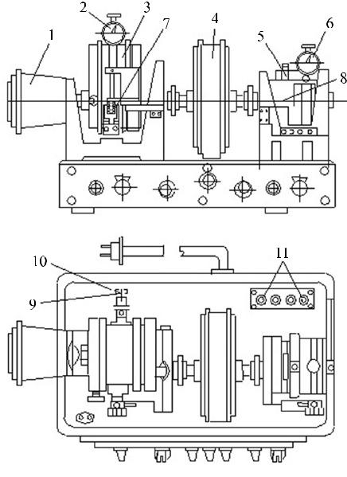
Fig. 6.1. The bench for testing a planetary gear reductor

The loading device is a magnetic powder brake. The braking moment created by it is transmitted to the end shaft of the reductor. Its structure and operation are the same as those of the brake.
The torques of the engine and the brake may be measured by an oscilloscope as well. For the said purpose, resistance strain gauge sensors shall be glued on the measuring springs 7 and 8 that are connected to the oscilloscope through an amplifier. It is accomplished using the contact terminals 11.
For calibration of the springs, levers shall be fixed: the smaller lever with a 0.1 kg plummet shall be fixed to the engine and the bigger lever with a 1.0 kg plummet shall be fixed to the brake. If the torques are measured by an oscilloscope, the results are multiplied by the oscilloscope grid division value, not by the one of the indicator.

Procedure of the work

- Remove the hood from the reductor and examine the structure or the reductor. Draw its kinematic scheme.
- Upon turning the shaft of the electric engine manually, set the reduction rate of the reductor according to the equation (6.1)
$u=\frac{n_{1}}{n_{2}}$
- Calculate the number of teeth and check the obtained reduction rate of the reductor according to the equation (6.2):
- Calibrate the indicator for the engine torque measuring as follows:
  - Zero indicator’s dial. Fix a bar to the stator’s tang.
  - Put the plummet at the zero scale division of the bar and write down the reading of the indicator in the Table 6.1.
  - Push the plummet on the bar to new positions 3, 6, 9, 12 and 15 cm and fix the relevant readings of the indicator in the Table 6.1.
  - Calculate the calibration constant for each range:
$$k_{1i}=\frac{{∆T}_{i}}{h_{1i}-h_{1i-1}}\text{; (6.4)}$$
here: h_{1i} – the reading of the indicator when the plummet is in the position i; h_{1i−1} – the previous reading of the indicator when the arm of the plummet was 3 cm shorter; ΔT₁ - the increase of the torque created by the plummet when the arm increases by 3 cm.
The mass of the plummet m₁ = 0.1 kg.
Its weight F₁=m₁ ∙ g=0.1∙9,81=0,981N,
ΔT₁ = m₁ ⋅ g ⋅Δl₁ = 0,1⋅ 9,81⋅ 0,03 = 2,943 ⋅10⁻² Nm.
Fill in the results in Table 6.1.

  - Find the arithmetic average of the calibration constants k_{1i} - it shows the torque of the engine that corresponds to one scale division of the indicator:
$$k_{1vid}=\frac{Σk_{1i}}{n} \left[{Nm}/{mm}\right]\text{; (6.5)}$$
here: n – the number of measurements.
  - Calculate corresponding torque values according to formula T₁=k_{1vid}∙h₁ and fill in the table 5.1.
  - Draw the calibration curve h₁ = f(T₁).
- Calibrate the indicator for measuring the braking torque as follows:
  - Set indicator to zero. Fix a bar to the body of the brake.
  - Put 1kg plummet at the zero scale division of the bar and write down the reading h₂ of the indicator in the Table 6.2.
  - Push the plummet on the bar to new positions 4, 8, 12, 16 and 20 cm and fix the relevant readings of the indicator in the Table 6.2.
  - Calculate the calibration constant for each range:
$$k_{2i}=\frac{{∆T}_{2}}{h_{2i}-h_{2i-1}}\text{; (6.6)}$$
here: h_{2i} – the reading of the indicator when the plummet is in the position h (rpm); h_{2i-1} – the previous reading of the indicator when the arm of the plummet was 4 cm shorter; ΔT₂ - the increase of the torque created by the plummet when the arm increases by 4 cm.
The mass of the plummet m₂ = 1,0 kg.
Its weight F₂ = m₂ · g = 9,81 N.
Then ΔT₂ = m₂ ⋅ g ⋅ Δl₂= 1⋅ 9,81⋅ 0,04 = 0,392 Nm.
Fill in the results in Table 6.2.
  - Find the arithmetic average of the calibration constants k₂ - it shows the braking torque that corresponds to one scale division of the indicator:
$$k_{2vid}=\frac{{Σk}_{2i}}{n} \left[{Nm}/{mm}\right];$$
here: n – the number of measurements.
  - Calculate corresponding torque values according to formula T₂=k_{2vid}∙h₂ and fill in the table 6.2.
  - Draw the calibration curve h₂ = f(T₂).
- Establish the dependence of the efficiency factor on the load.
  - Switch on the engine. Set one of the following rotational frequencies according to your data sheet values:
- n₁ = 600 rpm;
- n₂ = 800 rpm;
- n₃ = 1000 rpm;
- n₄ = 1200 rpm;
- n₅ = 1400 rpm;
Attention. During the experiment, observe whether the value of n₁ is constant. If it changes, adjust it.
  - Increase the braking torque by the magnetic power brake (with a step of 0.5 mm), thus causing varying on the load of the reductor. The values of the torque are shown by the indicator fixed to the brake. Fix the found values of h₁ and h₂ in the Table 6.3.
  - Establish the torques T₁ and T₂ from the calibration curves of the values of h₁ and h₂ found in the paragraphs 4.7 and 5.7 and fill them in the Table 6.3.
  - Using the equation 6.3, find the efficiency factor for each case of T₁ and T₂. Fix the results in the Table 6.3.
- Establish the dependence of the efficiency factor on the rotational frequency: η = f (n₁).
  - According to the schedule of works, set one value of the following values of the torque T₂:
  - T₂ = 1.0 Nm;
  - T₂ = 1.2 Nm;
  - T₂ = 1.4 Nm;
  - T₂ = 1.6 Nm;
  - T₂ = 1.8 Nm;
Attention. During the experiment, observe whether the value of T₂ is constant. If it changes, adjust it.
  - Upon varying the feeding current of the obtain various values of the rotational frequency n₁. Starting from the lowest value and increasing it by 200 RPM each step. Fill them and the values h₁ of the engine torque shown by the indicator in the Table 6.4.
  - From the calibration curve h₁ obtained in the paragraph 4.7, find values of T₁ for the values of h₁ and fix them in the Table 6.4.
  - Using the equation 6.3, find the efficiency coefficient for each case of n₁ and T₁. Fix the results in the Table 6.4.
- Draw the diagrams η = f (T₂) and η = f (n₁).
- Formulate your conclusions about the studied reductor

Report of laboratory work 6
THE STUDY OF A PLANETARY REDUCTOR

- Kinematic schematic of planetary reductor.
- Calculation of reductor reduction rate using one of the methods.
I method. By rotation frequency ratio of the shafts.
First shaft rotation frequency: n₁=..................
Last shaft (lead) rotation frequency: n₂=..................
Reductor transfer rate:
$$u=\frac{n_{1}}{n_{2}}=$$
II method. By number of teeth of the gears.
Number of teeth of the first gear: z₁=...............
Number of teeth of the first satellite gear z‘₁=..............
Number of teeth of the second satellite gear z‘₂=..............
Number of teeth of the third (stopped) satellite gear z_{3st.}=.............
Reductor transfer rate:
$$u=1-\frac{z_{1}^{'}∙z_{3st.}}{z_{1}∙z_{2}^{'}}=$$
- Calibration of motor torque measuring indicator.
Table 6.1. Calibration of the engine indicator
Arm of the plummet (cm) | Indicator readings h₁ (mm) | Calibration coefficient k_{ti} | Rotation torque T₁
0
3
6
9
12
15
18
21

Calibration coefficient is calculated for each interval:
$$k_{1i}=\frac{{∆T}_{i}}{h_{1i}-h_{1i-1}}$$
Average of all k₁ calibration coefficients:
$$k_{1vid}=\frac{Σk_{1i}}{n}=$$

Rotation torque is calculated for each interval:
$$T_{1}=k_{1vid}∙h_{1}$$

Calibration curve h₁ = f(T₁ ).
h₁ = f(T₁ )

- Calibration of break torque measuring indicator.
Table 6.2. Calibration of the brake indicator.
Arm of the pummel (cm) | Indicator readings h₂ (mm) | Calibration coefficient k_{2i} | Rotation torque T₂
0
4
8
12
16
20
24
Calibration coefficient is calculated for each interval:
$$k_{2i}=\frac{{∆T}_{2}}{h_{2i}-h_{2i-1}}$$
Average of all k₂ calibration coefficients:
$$k_{2vid}=\frac{{Σk}_{2i}}{n}=$$
Rotation torque is calculated for each interval:
$$T_{2}=k_{2vid}∙h_{2}$$

Calibration curve h₂ = f(T₂ ).
h₂ = f(T₂ ).

- Calculation of efficiency coefficient dependency on load.
Motor rotation frequency according to data from schedule: n₁=…………………..RPM
Table 6.3. Efficiency coefficient dependency on load.
Measurement No. | Motor |  | Brake |  | Efficiency coefficient η
 | Indicator readings h₁ (mm) | Torque T₁ (Nm) | Indicator readings h₂ (mm) | Torque T₂ (Nm)
1 |  |  | 0,2
2 |  |  | 0,5
3 |  |  | 0,8
4 |  |  | 1,1
5 |  |  | 1,4
6 |  |  | 1,7

- Calculation of efficiency coefficient dependency on rotation frequency.
Brake torque according to data from schedule: T₂=……………..Nm.
Indicator value corresponding to torque T₂, taken from brake calibration curve: h₂=………………..mm.

Table 6.4. Efficiency coefficient dependency on rotation frequency.
Measurement No. | Motor rotation frequency n₁ (RPM) | Motor |  | Efficiency coefficient η
 |  | Indicator readings h₁ (mm) | Torque T₁ (Nm)
1
2
3
4
5

- Efficiency coefficient dependency graphs:
η = f(T₂)
η = f(n₁).

- Conclusions:

Work done by:

Work accepted by:

LABORATORY TEST 7

THE DETERMINATION OF THE CRITICAL VELOCITY OF THE SHAFT

The abbreviations and their meanings:

C – the shaft-bending centrifugal force;
m - the unbalanced mass of the shaft;
m_{d} - the mass of the disc;
m_{v} - the mass of the shaft;
m_{p} - the mass of the additional weight;
n_{kr} – the critical rotational frequency;
D_{v} – the diameter of the shaft;
ω- the angular velocity of the shaft;
ω _{k r}- the critical velocity of the shaft when it may break upon certain conditions;
y – the bending of the shaft caused by the centrifugal force;
I - the moment of inertia of the shaft cross-section;
E – the modulus of elasticity of the material of the shaft;
L – the length of the shaft;
e – the eccentricity (the distance of the concentrated mass of the oscillating system from the axial rotation line);
k – the rigidity of the shaft;
w_{max} – the maximum frequency of angular rotation of the shaft;
w_{1 kr} – the theoretical critical velocity of rotation of the unloaded shaft;
w_{2 kr} – the theoretical critical velocity of rotation of the shaft loaded with an additional weight of the mass m₁;
w_{3 kr} – the theoretical critical velocity of rotation of the shaft loaded with an additional weight of the mass m₂;
w^{e}_{1 kr} – the experimental critical velocity of rotation of the unloaded shaft;
w^{e}_{2 kr} – the experimental critical velocity of rotation of the shaft loaded with the mass of the additional weight;
w^{e}_{3 kr} – the experimental critical velocity of rotation of the shaft loaded with the mass of the additional weight;
The critical velocity of the shaft

A resonance occurs, when the critical velocity of shaft is reached, i.e. when the frequency of the change of the external forces coincides with the natural frequency of the system consisting of the shaft and its elements. Then the amplitude of the oscillations suddenly increases and it may reach such a magnitude when the structure of the shaft may break.
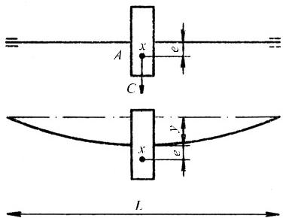
Let’s suppose that a disc is symmetrically fixed on the shaft L (Fig. 7.1).
Fig. 7.1. The scheme of a shaft with a disc

For the sake of simplicity, let’s assume that the mass m of the oscillating system is concentrated at point A. It is considered that approximately mass m consists of the sum of the whole mass of a disc and a half mass of a shaft. The eccentricity e is the distance of the point A from the axis of revolution. When the shaft begins to revolve, the unbalanced mass m bends the shaft by the centrifugal force C:
C = mω² ( y + e).
The bending of the shaft caused by the said force:
$$y=\frac{CL^{2}}{48EI};$$
here E - the modulus of elasticity of the shaft material; I - the moment of inertia of the shaft cross-section.
$$\text{The ratio } \frac{48EI}{L^{3}} \text{is called a value k.}$$
Then
$$c=\frac{48∙E∙I}{L^{3}}y=ky, k=\frac{c}{y}.$$
Thus k - the rigidity;
c – the force causing the bending of the shaft;
y – the bending of the shaft.
So
$$m\left(y+e\right)ω^{2}=ky$$
and
$$y=\frac{e}{\frac{k}{mω^{2}}-I}.$$
$$m=m_{d}+0,5∙m_{v}.$$
From here, when $ω=\sqrt{k/m}$ we obtain y ∞.
It means that at this angular velocity, the shaft must break. So, we call this velocity critical, i.e.
$$ω_{KE}=\sqrt{\frac{k}{m}.}$$
When the velocity of the shaft is close to the critical velocity, it begins to vibrate violently. When it is in marginal operation for a long time, the shaft may break. But it cannot break suddenly, because of the resistance in it, such as internal friction, friction in the supports etc. It is known than when ω = ω_{NE}, the bending of the shaft is the largest. Leaving quickly this zone, the shaft will rotate smoothly. That is why shafts operate well even when the rotational speed n > n_{NE}. Such shafts are called flexible.
When ω ∞ and y e, the shaft is self-balancing. To avoid a resonance, thick and rigid, deformation-proof shafts are used.
Aim of the work

- To calculate the critical velocity of the shaft theoretically.
- To determine the critical velocity of the shaft experimentally.
- To compare the obtained values and to make conclusions.

Description of the test bench

The test bench DM32 (Fig. 7.2) of a shaft 28 with one disc 23. The shaft rotates in two spherical ball bearings which are fastened in the front support 37 and the back support 39. The shaft is revolved by the universal commutator motor 31 through an elastic coupling 30. The motor also revolves the tachogenerator 33 through the coupling 35. Both the couplings are covered with convexes 36 and 29. After a shift, the disc is fixed on the shaft by the collet 24. In order to increase the mass of a disc, additional disc-shaped weights can be screwed up on it. The bolt 22 can be screwed into one of the discs and the disc will have unbalanced mass.
The front support 37 of the shaft is immovable. The rigidity of the shaft may be changed by shifting the back support 39. The said support consists of the poppet 19 which shifts on a bolt on turning the handle 17. The shifted poppet is fixed by the handle 40. The bushing with the bearing is fixed on the shaft by the collet 20.

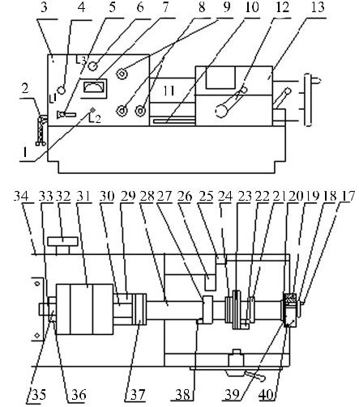
Fig. 7.2. The test bench for determination of the critical velocity of a shaft

When the shaft achieves the critical number of revolutions, two brackets, 21 and 27, with polyethylene bushings limit the amplitude of oscillations of the shaft and prevent it from breaking. The contact device 38 on the bracket 27 switches on the red lamp 7 when a resonance starts.
The rigidity of the shaft is measured by the mass 16 and the stand 15 with a crossbeam in which indicator 14 is fastened (fig. 7.3).
The shaft with a disc, the back support and both the brackets are covered by the movable convex 13. There is an opening in it for observing. The shaft between the front support and the left bracket is covered by immovable convex (11).
The convex 13 on four-wheeled guides moves in the both directions to the fixing arm 26. In the left, middle and right positions, the convex is fixed by the handle 12
The interlock contact 25 with a button cuts off the current when the convex 13 is in a wrong position. Therefore, when the convex 13 is in the left or the right position, a cam moves from the button and the motor stops. In order to put the convex in the middle position, it is necessary to take off the indicator’s cross-beam 15 and the mass 16. Otherwise the convex will not close.
The panel 3 covers the motor, the front support of the shaft and the tachogenerator.
There are ventilation openings in the back wall of the bench. The front wall of the panel includes:

1 – a button for switching off the signal lamp 7;
4 – a lamp indicating that the bench is switched on;
5 – an omnipolar switch for switching off the whole bench;
6 – a tachometer;
7 – a lamp indicating the start of a resonance;
8 – a switch for starting and stopping the motor;
9 – a handle for smooth regulation of the motor’s rotational speed.

The bench is grounded by the screw 32.

Data of the bench
- Power of the motor – 0.18 kW.
- Diameter of the shaft D_{v} – 12 mm.
- Disc mass m_{d} – 2 kg.
- Shaft mass m_{v} – 0.4 kg.
- Additional weight mass m_{p} – 0.35 kg.
- Maximum eccentricity – 0.245 mm.
- Force of mass bending the shaft c – 79.5 N.

Procedure of the work

- Take off additional discs.
- Fix the indicator above the shaft.
- Hang a hook with a static weight behind the lower edge of the disc.
- Determine shaft bending y by the indicator.
- Calculate the shaft rigidity k.
- Calculate the critical velocity of the shaft for three cases:
  - without additional weight;
  - with one additional weight;
  - with two additional weights.
- Take off the static weight.
- Take off the indicator.
- Close the convex.
- Switch on the motor and smoothly increase the rotational velocity of the shaft.
- Fix the resonance; increase the velocity beyond the critical zone. Decrease the velocity and fix the resonance again. Determine an arithmetic mean of both critical velocities for three cases: without additional weight, with one additional weight and with two additional weights.
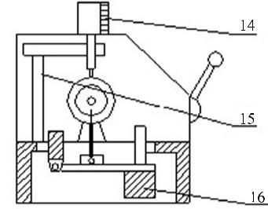
- Compare the theoretical values of the critical velocity to their experimental values and make conclusions.
Fig. 7.3. Measuring the rigidity of a shaft
1 | Switch of lamp L2 | 15 | Stand with a cross-beam | 29 | Convex
2 | Conductor | 16 | Weight | 30 | Couple
3 | Wall of the panel | 17 | Handle | 31 | Electric motor
4 | Lamp L2 | 18 | Flywheel | 32 | Grounding screw
5 | Omnipolar switch | 19 | Poppet | 33 | Tachogenerator
6 | Milliammeter | 20 | Collet | 34 | Back cover
7 | Lamp L3 | 21 | Right bracket | 35 | Couple
8 | Starting and stopping button | 22 | Bolt | 36 | Convex
9 | Velocity control unit | 23 | Disc | 37 | Front support
10 | Limiter | 24 | Collet | 38 | Contact device
11 | Immovable convex | 25 | Interlock contact | 39 | Back support
12 | Handle | 26 | Fixing arm | 40 | Handle
13 | Movable convex | 27 | Left bracket | 41
14 | Indicator | 28 | Shaft | 42

Report of laboratory work 7
Determination of the shaft’s critical velocity

- Calculation of the shaft stiffness.
Calculated shaft bend: y =.................mm=.....................m.
Force, causing shaft to bend: c = ................N.
Shaft stiffness k:
$$k=\frac{c}{y}=$$
- Calculation of theoretical critical velocity.
2.1. Critical velocity, when disc has 0 extra load.
Overall shaft mass:
$$m=m_{d}+0,5∙m_{v}=$$
Critical angular velocity:
$$ω_{1kr}=\sqrt{\frac{k}{m}}=$$
Critical rotational speed:
$$w_{1kr.}=\frac{ω_{1kr}∙30}{π}=$$
2.2. Critical velocity, when disc is loaded with 1 extra weight:
Overall shaft mass:
$$m=m_{d}+0,5∙m_{v}+m_{p}=$$
Critical angular velocity:
$$ω_{2kr}=\sqrt{\frac{k}{m}}=$$
Critical rotational speed:
$$w_{2kr.}=\frac{ω_{2kr}∙30}{π}=$$
2.3. Critical velocity, when disc is loaded with 2 extra weights:
Overall shaft mass:
$$m=m_{d}+0,5∙m_{v}+2∙m_{p}=$$
Critical angular velocity:
$$ω_{3kr}=\sqrt{\frac{k}{m}}=$$
Critical rotational speed:
$$w_{3kr.}=\frac{ω_{3kr}∙30}{π}=$$

- Findings of experimental critical velocity:
Experimental critical rotational frequency (RPM)
Disc without extra weights W^{e}_{1kr.} | One additional weight  W^{e}_{2kr.} | Two additional weights  W^{e}_{3kr.}

- Conclusions:

Work done by:

Work accepted by:

LABORATORY TEST 8

THE STUDY OF A SLIDING BEARING

The abbreviations and their meanings

F_{ir} – fluid friction;
F_{r} – the radial force (the weight of the shaft);
µ – the coefficient of fluid friction;
T – the frictional torque in the bearings;
I – the moment of inertia of the shaft;
ω – the angular speed;
ω_{n} – the angular speed in the beginning of the measurement;
ω_{n+1} – the angular speed in the end of the measurement;
t – the time interval of the measurement;
d – the diameter of the journal;
P – the pressure of the lubricant in the bearing;
l – the length of the journal;
M₁, M₂, M₃ – the manometers;
ϕ - the angle of rotation of bearing with respect to the vertical;
$\frac{dω}{dt}$ - the angular speed of the shaft.
THE SLIDING BEARINGS AND FRICTION IN THEM

Sliding bearings are supports for elements of rotating details; the said elements support on them and slide on their surface. The simplest sliding bearing is a cylindrical bush fixed in the machine frame or a part of the frame with a cylindrical hole where the journal of the rotating shaft is sliding on its surface.
According to direction of the taken load, sliding bearings are divided to two main groups – radial and axial. Radial bearings take loads perpendicular to the axis of the shaft and the axial bearings take loads in the longitudinal direction with respect to the axis of the shaft. If a radial force and an axial force are acting simultaneously, usually a combination of a radial bearing and an axial bearing is used.
To avoid an attrition of rubbing surfaces or to minimize it to the maximum possible extent, the sliding surfaces should be separated by a film of a lubricant. If a shaft rotates in the media of the lubricant, such a film is formed, when a certain speed is achieved. Such a lubrication mode is referred to as hydrodynamic lubrication and bearings working in the said mode are referred to as hydrodynamic bearings. Otherwise, a film of a lubricant may be formed by feeding a compressed lubricant to the contact zone from outside. Such bearings are referred to as hydrostatic bearings. They are usable for supporting slowly rotating machine shafts affected by heavy loads, when low friction is required and hydrodynamic lubrication is not achieved. In such bearings, the required pressure in the film of the lubricant is created by the compressor that feeds the lubricant to the friction zone. The required pressure should enable the lubricant to separate the rubbing surfaces of details of the bearing. Hydrostatic bearings are also usable when the accuracy of shaft alignment should be increased and the attrition in a hydrodynamic bearing should be reduced on run-up and braking.

Air may play the role of a lubricant as well. If an airbag that separates the rubbing surfaces in a bearing is formed by itself, such bearings are referred to as aerodynamic bearings. Such bearings are used when shafts are affected by low loads and their rotational speed is very high, i.e. n > 10’000 min. – 1. Alternatively, an airbag may be formed in an artificial way by feeding compressed air to the friction zone. Such bearings are referred to as aerostatic bearings. When air is used as a lubricant, very low friction is ensured.
In practice, hydrodynamic bearings are most widely used.
Usually, sliding bearings are the ones of a simple structure. They may be dismountable and undismountable. In case of fluid friction, their coefficient of friction should be very low – 0.005 min. -1 or less. The film of lubricant in the bearings damps vibrations and noise, reduces sensitivity to shocks. The rotational frequency of the shafts in sliding bearings may be very high and their service life, in case of adequate lubrication, may be almost unlimited.
Sliding bearings should be thoroughly lubricated and maintained. They need much lubricant. Materials of a bearing should be resistant to attrition. The sliding surfaces should be of high quality. In hydrodynamic bearings, high friction appears during the run-up. For hydrostatic bearings, special equipment for lubricant preparation and application is required that predetermines the functionality of the bearings.

Lubrication and cooling of bearings

Lubricant shall be permanently fed to the sliding space (zone). For this purpose, grooves or holes (in parallel with the axis) are made in the bush of the bearing and they ensure distribution of the lubricant over the whole width of the bearing. To facilitate getting of the lubricant to the friction zone, the edges of the grooves should be well rounded.
To minimize the lubricant leak through the sides of the bearing, the length of the whole groove should be shorter than the width of the bearing. However, it should be also planned how to remove the attrition products from the groove. For this purpose, it is recommended to make narrower axial notches in the ends of the groove. In bearings lubricated in the hydrodynamic way, the lubricating grooves should be located in non-rotating pressure-free zone, because otherwise the film of the lubricant will be interrupted. For lubrication of sliding bearings, plastic and liquid lubricants are usable.
Plastic lubricants are usable for lubricating less loaded bearings and knuckles as well as bearings operating in dusty media. Lubricant excess does not drop away from the bearing; it is accumulated in its ends and forms a cordon against impurities. If plastic lubricants are used, only the state of mixed friction is achievable. When the sliding speed exceeds 2 m/s, use of plastic lubricants is not recommended. For lubricant feeding to the lubrication zone, special lubricating equipments, referred to as lube boxes, are used. Their operation is based on extrusion of the lubricants from cavities. Pressure in the lubricant is formed by periodic rotation of a screw as well as by a spring or the gravity force.
Liquid lubricants (oils) are more frequently used. Knuckles and lower accuracy easily accessible bearings are usually lubricated manually. From the lube box (lubricator), the oil is extruded to the lubricating channels. To avoid impurities from outside, their entrance should be closed when lubrication does not occur.
Hydrodynamic lubrication systems may be used as well. Their principal element is a drop-feed dispenser. One end of the dispenser is immersed in a bath with oil and oil drops from its other end to the lubrication zone.
Simple and effective method of lubrication is splash of bearings. For this purpose, special rings or other elements are provided in the bearing or close to it.

For lubrication of highly-loaded bearings, circulation systems are used. Their principal element is a pump that collects the oil leaked from the bearing and then through the filter and the cooler feeds it back to the lubrication zone. This method ensures both good lubrication and cooling.
For lubrication of bearings, oil mist generated in housings of some machines may be used. For this purpose, lubrication channels for collecting the leaking oil splashed on the walls of the frame should be provided.
Friction causes heating of sliding bearings. The released quantity of heat depends on the structure of the bearing, its size, the friction coefficient and the sliding speed.
Bearings with low sliding speeds cool down without special means. The generated heat is released to the environment through the bearing and its frame. If facets are made on the surface of the frame, they increase the area of contact with air and cause more intensive cooling.
The permissible temperature of a bearing is 70-90 ºC. If the said temperature is exceeded, special cooling means should be applied. Released heat is effectively removed by a circulation system of lubrication that includes a cooler. If, in addition to cooling of bearings, the heat released in other parts of the machine should be removed, cooling by water circulating in channels in the frame of the machine is purposeful. Usually, the fed water is not repeatedly used.
Good cooling is ensured by air flow created by a special ventilator equipped for this purpose or by movement of the machine. Heat released in the bearing may be also removed by a thermally conductive shaft; however, such a shaft should protrude out from the machine and be blowed over by the surrounding air. For higher efficiency of cooling, aluminum discs are fixed on the protruded end of the shaft and rotate together with it.
Sliding bearings usually require systematic maintenance and uninterrupted lubrication. They distinguish themselves for high friction losses, they require higher starting moments, but their operation is more accurate and silent, as compared to rotating bearings.

The modes of sliding friction

Dry friction takes place when asperities of two surfaces enter into contact. When such surfaces are moving and overcoming together the forces of molecular attraction, plastoelastic deformation and partial destruction of the contacting asperities are inevitable. In case of dry friction, the contacting surfaces wear rapidly; in addition, vibrations and high energy losses appear.
For boundary friction, a very thin absorbing layer of lubricant film is typical. Formation of such a film is predetermined by adhesive properties of the lubricants. The thickness of such a film (that is similar to thinnest silk velvet) is close to sizes of molecules.
For fluid friction, rather thick layer of lubricant that exceeds the summarized heights of asperities of work surfaces and the sizes of solid particles that may appear in the lubricant on its pollution is typical. Fluid friction is understood as an internal friction of fluid. While speaking about fluid friction, it should be kept in mind that the rubbing surfaces are totally separated by the layer of lubricant. In such a mode, the working conditions of the machine are favourable: the energy losses are considerably reduced and no attrition takes place.
The ratio of the fluid friction force F_{ir} and the force perpendicular to the surface N conditionally determines the fluid friction coefficient µ according to the analogy with the friction coefficient in the Coulomb’s law:
$$μ=\frac{F_{tr}}{N}$$

The fluid friction coefficient is considerably less, as compared to the dry friction coefficient or the boundary friction coefficient and depends on the viscosity of the lubricant.
The fluid friction appears, if the following principal requirements are satisfied:
- the lubricant is presented between the sliding surfaces;
- when the lubricated surfaces move, internal pressure appears in the layer of the lubricant and the said pressure counterbalances the external load that presses the sliding surfaces to each other;
- the lubricant completely separates the sliding surfaces;
- the layer of the lubricant between the sliding surfaces is no less than the minimum limit.
The principle of fluid friction is explained by examples.
Fig. 8.1. Hydrodynamic friction:
a – the scheme of appearance of the gap; the micro-profile of the gap

Let’s suppose that the front part of the top supporting surface of the slide inclines by a certain angle with respect to the top part of the guide.
When the slide A moves in the direction of the arrow V, pressure appears in the lubricant separating the surfaces of the slide and the guide, and the said pressure grows with growing of the slide’s speed. The appearing forces may raise the slide. If the thickness of the layer of lubricant exceeds the summarized height of the asperities (Fig. 8.1. b), fluid friction appears. The lubricating fluid should be viscous - in such a case, a thin film of lubricant adheres to the slide and moves with it.
In Fig. 8.2 a, the positions of the shaft and the bearing lining in the bearing are shown. The axle and the bearing lining adjoin by the generatrix; the projection of the latter is shown by the point A. In this fragment, there is no lubricant or its layer is very thin, because the lubricant is eliminated by the force P that affects the axle. When the axle starts rotating in the direction shown in Fig. 8.2 b, pressure appears in the lower right part of the axle (the epure of the pressure is shown in Fig. 8.2 b).
In the narrowest point, the diameter of the lubricant layer equals to h.
Fig. 8.2. The shaft in the sliding bearing: a – on standing; b – on rotation
When h > R_{z1} + R_{z2} (Fig. 8.2 b), fluid friction appears. For formation of a layer of lubricant, the diameter of the bush should be some bigger that the diameter of the axle, i.e. a gap should be provided between them.
The friction coefficient in the bearings may be found on free standing of the rotor and measuring the alteration of its speed (acceleration).
According to the Second Newton’s law:
$$T=I\frac{dω}{dt};\text{ (8.1)}$$

here T – the friction moment in the bearings; I – the moment of inertia of the rotor; dω/dt – the angular speed.
If the acceleration alters slightly:
$$\frac{dω}{dt}=\frac{ω_{n}-ω_{n+1}}{t};$$
here ω_{n} – the angular speed in the beginning of the measurement; ω_{n+1} - the angular speed in the end of the measurement; t = 60 s, i.e. 1 minute
$$\frac{dω}{dt}=\frac{ω_{n}-ω_{n+1}}{60}$$
or:
$$T=F_{tr}∙\frac{d}{2};$$
here F_{ir} – the tangential braking force on the surface of the shaft journal; d – the diameter of the journal.
Let’s replace F_{ir} = µ F_{r}
here: µ - the friction coefficient; F_{r} – the radial force (the weight of the rotor).
$$T=F_{r}μ\frac{d}{2}\text{ (8.2)}$$
While comparing (8.1) and (8.2), we obtain:
$$I\frac{ω_{n}-ω_{n+1}}{30dF_{r}}=F_{r}μ\frac{d}{2}$$
From the above, we obtain:
$$μ=I\frac{ω_{n}-ω_{n+1}}{30dF_{r}}$$

Aim of the work

To establish the friction coefficient µ of a sliding bearing.
To draw the curves of pressure in bearings according to the dependences P = f (ϕ) and P = f(l).
The equipment TMM7M (Fig. 8.3) consists of a cast basis (19) where the bearing with the rotor are mounted, a body with a braking
equipment (20), flywheels (5), a rotating mechanism and a control panel (10). The rotor is mounted in the cast frame (18) and rotates in a bronze bush (17). Two cast flywheels (5) are fixed with brackets on the shaft of the rotor. The rotor is cranked by the electric engine (9) through the conical friction clutch (6). The engine is started up by the handle (8).
Alteration of the angular speed of the shaft journal is achieved by self-braking (friction in the bearing).
The rotational speed of the shaft journal is registered by an electromagnetic tachometer fixed on the same axle with the rotor journal in the side opposite to the drive. The time of reduction of the angular speeds of shaft journals in the established parts of several 1-minute periods is registered by a stop-watch. For establishing the loading power of the bearing, the following means are provided:
- three manometers (4) for measuring the pressure in three points of the lubricant layer situated along the generatrix of the shaft journal (Fig. 8.4);
- the scale (1), the needle, the handle and the fixer (3) for rotating the bush of the bearing by an angle not exceeding ±30º in respect of the vertical.
The friction mode is controlled by changes of the pressure in the manometers as well as by two special signal lamps on the control panel. On starting-up the flywheels, the left signal lamp (16) is lighting; when the lubricant layer appears and the contact between the shaft journal and the bush of the bearing is broken, the left lamp is gradually going down and the right signal lamp (14) lights up.
The data of the test-bench:
F_{r} = 1120 N - the weight of the rotor;
I = 2.6 kgm² – the moment of inertia of the rotor;
d = 0.05 m - the diameter of the shaft joint.
The friction coefficient is found on free deceleration of the rotor from the maximum rotational speed.

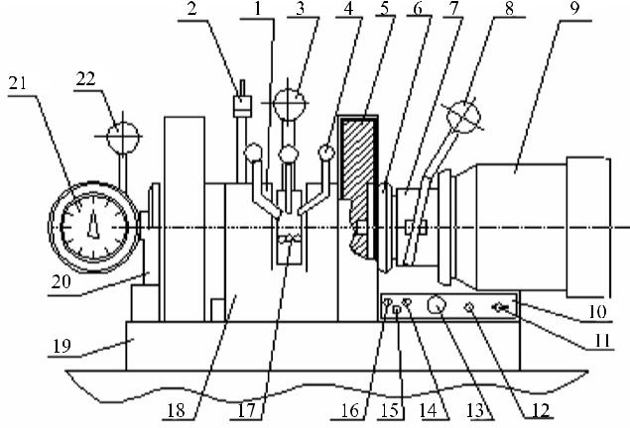
Fig. 8.3. The test-bench for a sliding bearing

Fig. 8.4. The scheme of disposition of manometers in the bearing
Procedure of the work

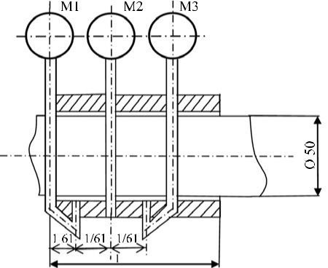
- Start-up the rotor until it achieves the maximum rotating frequency; then switch off the electric engine.
- Simultaneously start-up the stop-watch and register the speed of the rotor each minute.
- According to the obtained data, draw the rotor’s deceleration curve ω = f (t).
- According to the formula (8.3), calculate the coefficient µ of friction in the bearings for each minute of deceleration.
- Find the pressure in the bearings by the manometers M₁, M₂, M₃ at the rotating frequency specified by the university teacher.
- Carry out measurements of pressure on varying the angle of rotation of the bearing with a step of 15º.
- Draw the curve of dependence of pressure on the angle ϕ in polar coordinates.
- Draw the curve of dependence of pressure on the distance from the edge of the bearing.

Report of laboratory work 8
STUDY OF A SLIDING BEARING
- Calculation of friction coefficient.
Value of a step on monometer scale:………………………………
Determination of rotational frequency dependency on time:
Table 8.1. Rotor rotational frequency dependency on time.
Elapsed time t, min | 0 | 1 | 2 | 3
Rotor rotational frequency 𝛚, RPM
Rotor speed change throughout time ω = f (t ).
ω = f (t )

Calculation of friction coefficient.
$$μ_{n}=I\frac{ω_{n}-ω_{n+1}}{30dF_{r}}=$$
- Measurement of pressure inside bearings.
Table 8.2. Results of pressure measurements inside bearings.
Bearing rotation angle, 𝛗° | Manometer shown bearing pressure, P (kg/cm²)
 | M₁ | M₂ | M₃
0
15
30
45

Bearing pressure dependency on angle with added vertical in polar coordinates.
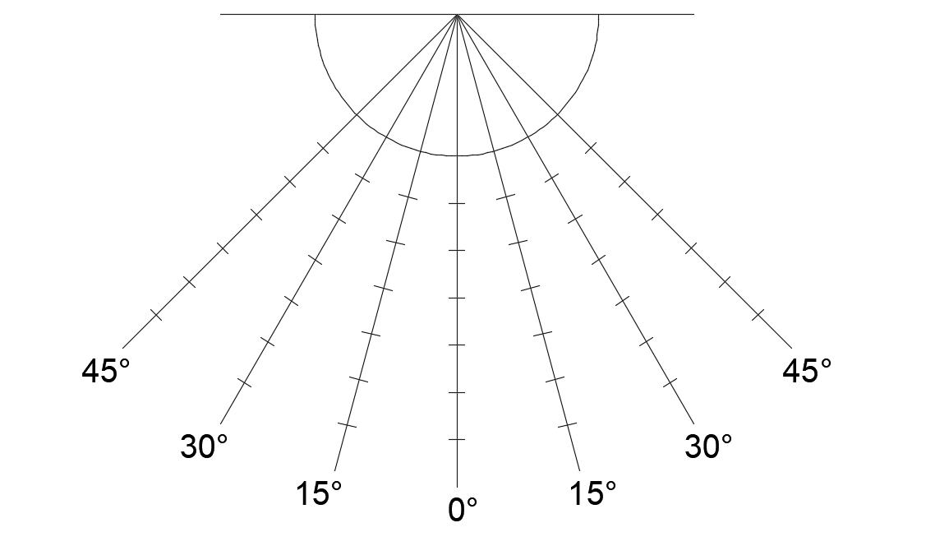
Bearing pressure dependency on a distance to edge of a bearing. P = f (l).
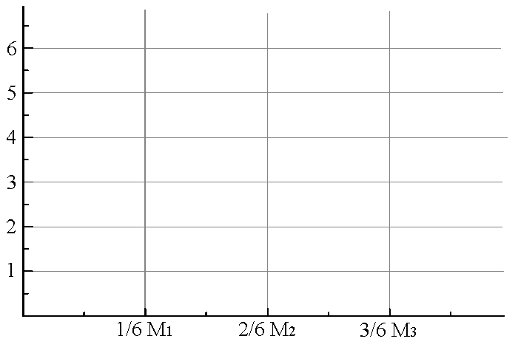
Conclusions:

Work done by:

Work accepted by:

Laboratory work 9
STUDY OF FRICTION IN ROLLING-CONTACT BEARINGS

The abbreviations and their meanings

F_{r} – the radial load of the bearing;
f_{s} – the arbitrary friction coefficient of the bearing;
T_{f} – the moment of frictional forces;
d – the diameter of the shaft.
n – the rotational frequency of the shaft

ROLLING-CONTACT BEARINGS AND FRICTION

The structure of bearings. Upon striving to avoid the imperfections typical for sliding bearings and, first of all, to reduce the friction losses, rolling-contact bearings were created – in them, sliding friction is replaced by rolling friction.
The key elements of a rolling-contact support are a body and a bearing with rolling elements (balls and rollers) in it. A rolling-contact bearing (Fig. 9.1) consists of the outer ring 1 and the inner ring 2; the rolling elements 3 move between their raceways A in the separator 4. The inner ring is mounted on the shaft and the outer ring is placed in the body. The rolling elements separate the body from the journal; on rotation of the frame or the journal, the rolling elements, while moving in the raceways, transmit a certain load from the journal to the body or vice versa (Fig. 9.2)
The materials. Rings and rolling elements of bearings are produced of high carbon chrome steel intended for production of rolling-contact bearings. Details made of the said material pass thermal processing until their rigidity achieved HRC 62-65; then they are ground and polished.
Separators of bearings are produced of soft carbon steel (stamped separators), brass, bronze, duralumin (cast separators) and textolite (textile laminate).
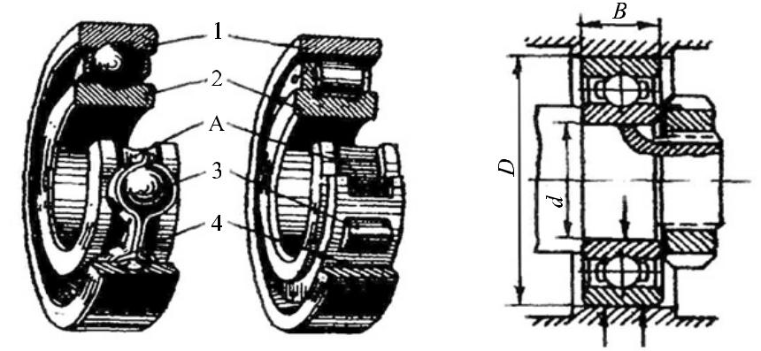
Fig. 9.1 Fig. 9.2

The advantages and imperfections of rolling-contact bearings. Recently, rolling-contact bearings are the most widely used supports for machines. They are widely standardized on the international scale and their mass-production is well-centralized.
The advantages of rolling-contact bearings, as compared to sliding bearings, are following:
- lower moments of frictional forces; much lower starting moment, as compared to sliding bearings;
- low consumption of lubricants;
- higher load carrying capacity per unit of area of the bearing, i.e. less sizes in the axial direction;
- use of non-ferrous metals for their production is not indispensable; lower requirements are set for materials of shafts and their thermal processing.
The imperfections of rolling-contact bearings include:
- less durability at higher velocities;
- large radial sizes; the bearings are undismountable in the radial direction;
- poor damping of oscillations.
Classification of bearings. Rolling-contact bearings are classified as follows:
- According to the direction of the supported load:
- radial bearings – the bearings that support only radial load perpendicular to the geometric axis of the shaft (see Fig. 9.2), or, in addition to the principal radial load, support a certain axial load;
- thrust bearings – the bearings that support a load applied along the axis of rotation (Fig. 9.3);
- radial thrust bearings – the bearings that support a combined load – radial and axial (Fig. 9.4.).
- According to the shape of the rolling elements (fig. 9.5): ball bearings and roller bearings.
According to the shape of a roller, the roller bearings are divided to: a) ones with cylindrical long and short rollers;
b) ones with convoluted rollers;
c) ones with tapered rollers;
d) ones with barrel-shaped rollers;
e) ones with needle-shaped rollers.
- According to the number of rows of rolling elements – single row bearings, double row bearings, four row bearings.
- According to the way of self-alignment: non-self-aligning bearings and spherical self-aligning bearings.
Rings of self-aligning bearings may tilt up to 2-3° and cause considerable deformations of the shafts and misalignment of holes for bearings in certain supports.
One of types of self-aligning bearings is presented by bearings with fastening hubs (Fig. 9.6); they may be fixed on smooth shafts.
Taking into account the ratio of the outer diameter D and the width B at a certain value of the diameter d, bearings are divided to the following series:
- according to the radial sizes – to extra light bearings, very light bearings, light bearings, medium bearings and heavy bearings;
- according to the width – narrow, normal, wide and very wide bearings.
The arbitrary marking. The arbitrary marking of rolling-contact bearings consists of numbers.

Third number from the right | 1 | 2 | 3 | 4 | 5 | 6
Mame of the series | Extra light | Light | Medium | Heavy | Light  Wide | Medium  Wide

The fourth number from the right shows the type of bearing:
- 0 - single row radial ball bearing;
- 1 – double row radial cylindrical ball bearing;
- 2 - radial bearing with short cylindrical rollers;
- 3 – double row radial spherical roller bearing;
- 4 – roller bearing with long cylindrical rollers or needles;
- 5 - roller bearing with convoluted rollers;
- 6 – supporting radial ball bearing;
- 7 – tapered roller bearing;
- 8 – thrust ball bearing;
- 9 – thrust roller bearing
Two first numbers from the right show the inner diameter of the bearing (the nominal diameter of the shaft in the zone of fitting the bearing), mm.
If the diameter of a bearing is from 20 to 495 mm, the said numbers equal to the inner diameter divided by 2. The third number from the right shows the series of the bearing.
The fifth and the sixth numbers from the right show the peculiarities of the structure.
The seventh number from the right shows the series of the bearing in respect of its width.

The principal types of ball bearings

Generally, ball bearings distinguish themselves for faster operation, as compared to roller bearings. Because the raceways of such
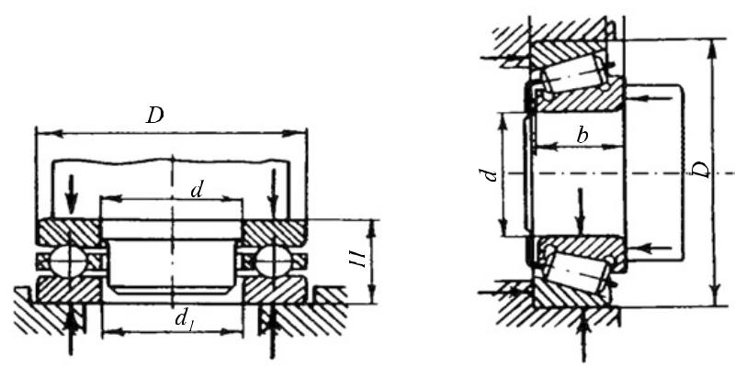
bearings are tray-shaped, they, in addition to withstanding the radial load, may fix the shaft in the radial direction; moreover, they may withstand axial forces in one or two directions. For such bearings, lower requirements related to alignment of holes and shaft rigidity are set, as compared to non-self-aligning bearings.
Roller bearings distinguish themselves for higher carrying capacity, as compared to ball bearings. Although roller bearings are similar to ball bearings in the aspect of fast operation, they do not support axial loads. Tapered roller bearings distinguish themselves for the same high carrying capacity both in the radial and the axial direction; there are fit for lower angular velocities; in addition, they should be regulated.
The normal of the tangent between the surfaces of the ball (roller) and the outer ring in radial and thrust bearings is not perpendicular to the axis of the shaft. Therefore, when such a bearing is affected by a radial load, reactive axial components S_{i} appear in the zones of contact that strive shifting the rings in respect of each other. The resultant force of the components S_{i} equals to their algebraic sum that is called the axial component of the radial load and marked S.
The rings cannot shift and will not shift, and the bearing is affected not only by the radial load, but also by an axial load that is equal to the axial component S or exceeds it.
Functionality of rolling-contact bearings highly depends on fixation of the shafts in the radial and axial direction; however, it should not affect an additional load caused by thermal deformations, excessive stretching on assembling and so on. So, mechanisms with them should be assembled very carefully. They are sensible to dust that is why units of bearings should be carefully sealed.
A classical rolling-contact bearing consists of the following principal parts (fig. 9.7):
* outer and inner rings with raceways;
* rolling elements;
* a separator
Fig. 9.3. A thrust ball bearing Fig. 9.4. A radial and axial
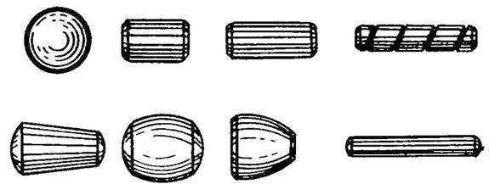
bearing with tapered rollers
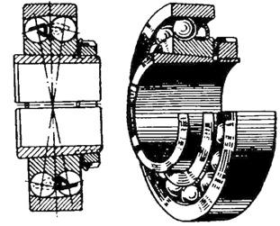
Fig. 9.5. Shapes of rolling elements
Fig. 9.6. A self-aligning double row radial cylindrical ball bearing

Fig. 9.7. The structure of a rolling-contact bearing: a – radial, b – axial

Bearings are usable as supports for rotating shafts or as elements of a support rotating on axles. Rotating machine elements are fixed by bearings in the axial direction as well. The load of shafts and axles is
transmitted by bearings to the body or the frame of the machine. Because bearings are intended for supporting the rotating elements, it is important to ensure their minimum resistance to rotational motion. For the said purpose, it is strived to minimize the frictional force in bearings to the maximum possible extent.
As it is known, the frictional force depends on many factors; the most important among them include:
- the force acting between rotating elements; and
- the coefficient of friction.
The force between elements of a bearing depends on the load that is determined. So, the frictional force may be reduced by reducing the coefficient of friction. Their interdependence may be expressed as follows:
$$T_{f}=F_{r}\frac{d}{2}f_{s}\text{ (9.1)}$$
here: T_{f} – the moment of frictional forces; F_{r} – the radial load of the bearing; d – the diameter of the shaft; f_{s} – the arbitrary friction coefficient of the bearing.
The friction coefficient of the bearing may be reduced by reducing the viscosity of the lubricant; however, such bearings require higher accuracy and additional complicated equipment. If sliding friction is replaced by rolling friction, the said imperfections may be avoided. This explains wide use of rolling-contact bearings (Fig. 9.8).
An absolute avoidance of energy losses in rolling-contact bearings is impossible. They appear because of:
- friction of rolling elements 3 and the raceways in the outer ring 1 and the inner ring 2;
- friction between the rolling elements and the separator 4;
- friction between the moving elements and the lubricant and stirring the lubricant.
In addition, the total friction losses depend on:
- the rotational frequency;
- the level of the lubricant;
- the viscosity of the lubricant;
- temperature etc.
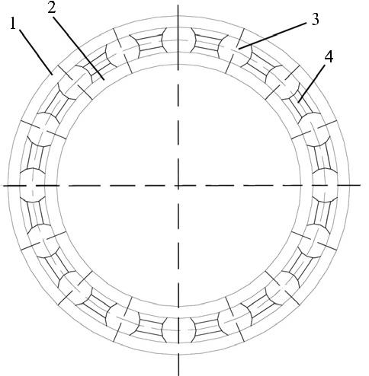
It is too difficult to determine all the above-mentioned factors theoretically. It is easier to measure the total moment of resistance in the bearing experimentally and then determine the total friction coefficient in the rolling-contact bearing. Usually, the total friction coefficient in the rolling-contact bearing determined in the experimental way is referred to as the arbitrary friction coefficient or the total friction coefficient reduced to the surface of the shaft. When the said coefficient is known, it is possible to find the resistance (friction) moment of the bearing from the equation (9.8). A reverse solution is possible as well: when the resistance moment is known, it is possible to calculate the arbitrary friction coefficient of the rolling-contact bearing.
Fig. 9.8. The scheme of a rolling-contact bearing: 1 – the outer ring; 2 – the inner ring; 3 – the rolling elements (balls); 4 – the separator.
Aim of the work

To find the total moment of frictional forces T_{f} and the arbitrary friction coefficient f_{s} reduced to the surface d of the shaft for different rolling-contact bearings upon taking into account the load and the rotational frequency of the inner ring.

The description of the test bench

The kinematic scheme of the test bench DM-28 for experimental determination of values of T_{f} and f_{s} is presented in Fig. 9.9. The electric motor 1 revolves the shaft 6 by means of V-belt drive 5 with three velocities (1.000, 2.000 and 3.000 rpm).
Fig. 9.9. The scheme of the test bench for investigation of friction in rolling-contact bearings
The motor is started up by the switch 3 placed on the body of the test bench. The connection to the mains is accomplished by the switch 8. The scale 2 calibrated in Nm shows the total moment of frictional forces T_{f} . Measuring the said moment by the strain-gauge (tensometric) method upon using the same test bench is foreseen as well. For this purpose, resistance strain gauge sensors are glued on the spring 7. They are switched into the measuring bridge by the contact terminals 4 and we obtain different indications of milliamperemeter at different deflections of the spring 7 caused by turning of the pendulum.
Bearings of various types are of different structures and have different friction losses. To compare different bearings, there are four changeable sets of heads which contain:
208 – single row radial ball bearings of light series;
308 – double row radial ball bearings of medium series;
1 208 - double row radial spherical ball bearings;
7 208 – radial and axial tapered roller bearings.
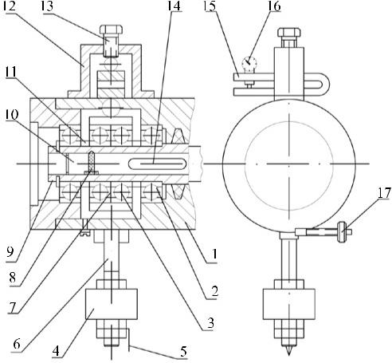
The structure of the head is shown in Fig. 9.10.
Fig. 9.10. The structure of the head of the bearings investigated
In the body 1, two external bearings 2 are built-in. Two internal bearings 3 are built-in in the casing 7. Inner rings of all four bearings are placed on the bush 9. The external bearings are separated from the internal bearings by distance sleeves 11. The bush 9 is fixed on the shaft of the laboratory bench key 14 and lock 8 on the shaft 10 of the laboratory bench.
The load is formed by the holder 12 with the screw 13 through the dynamometer 15 on pressing the casing 7. The value of the load is measured by the indicator 16. The calibration curve of the dynamometer is on the front wall of the body. The load causes a reaction in two internal bearings built-in in the casing 7. This load causes a reaction in the external bearings. The reaction is approximately equal to the load because the screw 13 and the external bearings are in the same body 1.
The load is absolutely equal to the reaction, if the weight of the head is deducted from the latter. The error is slight, so it is considered that all the four bearings are loaded equally.
The weight 4 and the pointer 5 are fastened to the pendulum 6. The moment of frictional forces T_{f} occurring in the bearings tends to turn the bearing head. However, the pendulum 6 with the weight will prevent the head from revolving and it will turn at a certain angle that corresponds to the value of the moment of frictional forces T_{f} . The pointer 5 is set at the zero point by means of adjusting weight 17.

Procedure of the work

  - Place the indicator into the dynamometer and set it at the zero point.
  - Check whether the pointer of the head pendulum is at the zero point of the scale and the dynamometer is free.
  - Switch on the bench and record the moment of frictional forces in absence of radial load in the table of the results.
  - Using the screw 13 (Fig. 9.10), form the load F_{r}: 2, 4, 6, 8 and 10 kN according to the calibration curve shown on the front wall of the test-bench. Adjust the moment of frictional forces for each load.
  - Perform the same gradually decreasing the load F_{r}.
  - Determine the reduced arbitrary coefficient of friction for each load
$$f_{s}=\frac{T_{f}}{d∙F_{r}};$$
here: T_{f} - the moment of frictional forces (Nm), F_{r} – the radial load (N); d – the diameter of the shaft (in this case, the outer diameter of the bush 9 (Fig. 9.10)) (or the inner diameter of the bearing) equal to 4 10⁻² m.
  - Substitute the head of the bearings by another one. However, use the same dynamometer.
  - Set the pointer of the pendulum at the zero point and check the zero position of the indicator.
  - Perform the procedures described in the items 3, 4 and 6.
  - Perform the same with the third head.

Report of laboratory work 9
STUDY OF FRICTION IN ROLLING-CONTACT BEARINGS

- Results of the measurements
Table 9.1. Dependencies of friction torque and coefficient on load.
Load  F_{r} | Bearing type
 | T_{f} | f_{s} | T_{f} | f_{s}
2000
4000
6000
8000
10000
12000

Calculated friction coefficients are filled in the table 9.1. according to formula:
$$f_{s}=\frac{T_{f}}{d∙F_{r}}$$

- Draw the curves of the dependencies f_{s}=f(F_{r}) for each type of bearings.
Bearing type……………….
f_{s}=f(F_{r}).

Bearing type………………….
f_{s}=f(F_{r}).

Conclusions:

Work done by:

Work accepted by:

